**NAME: ABHIJIT BARIK abro45172018@gmail.com**

**Table creation and value insertion:**

create database Assignment;

use  Assignment;

create table CITY

(

ID integer,

NAME VARCHAR(17),

COUNTRYCODE VARCHAR(3),

DISTRICT  VARCHAR(20),

 POPULATION  integer

);

insert into CITY values(6,'Rotterdam ','NLD','Zuid-Holland', 593321),

(3878, 'Scottsdale', 'USA', 'Arizona', 202705),(

3965, 'Corona', 'USA', 'California', 124966),

(3973, 'Concord', 'USA', 'California', 121780),

(3977,'Cedar Rapids', 'USA', 'Iowa', 120758),

(3982, 'Coral Springs', 'USA', 'Florida', 117549),

(4054, 'Fairfield', 'USA', 'California', 92256),

(4058, 'Boulder', 'USA', 'Colorado', 91238),

(4061, 'Fall River', 'USA','Massachusetts', 90555);

select * from CITY;

output:

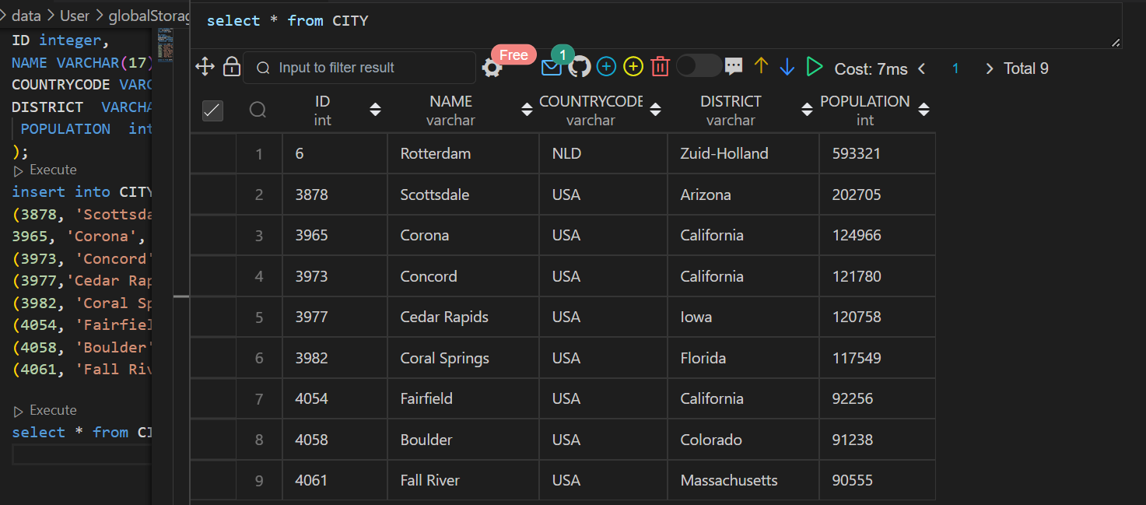

**Q1.**

**Query all columns for all American cities in the CITY table with populations larger than 100000. The CountryCode for America is USA. The CITY table is described as follows.**

SQL CODE:

SELECT *

FROM CITY

WHERE POPULATION > 100000 AND COUNTRYCODE = "USA";

OUTPUT:

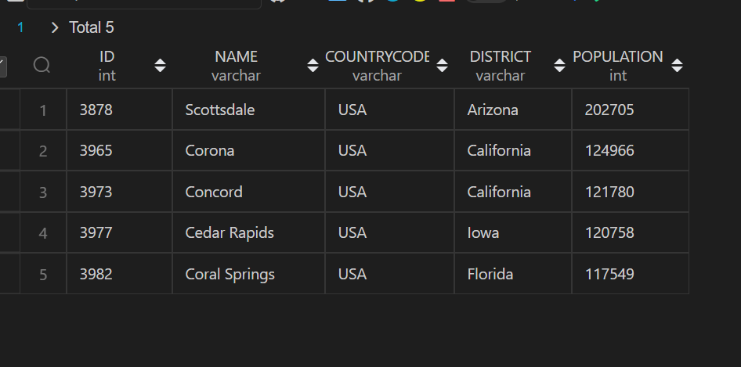

**Q2. Query the NAME field for all American cities in the CITY table with populations larger than 120000. The CountryCode for America is USA**

**SQL CODE:**

SELECT *

FROM CITY

WHERE POPULATION > 120000 AND COUNTRYCODE = "USA";

**OUTPUT:**

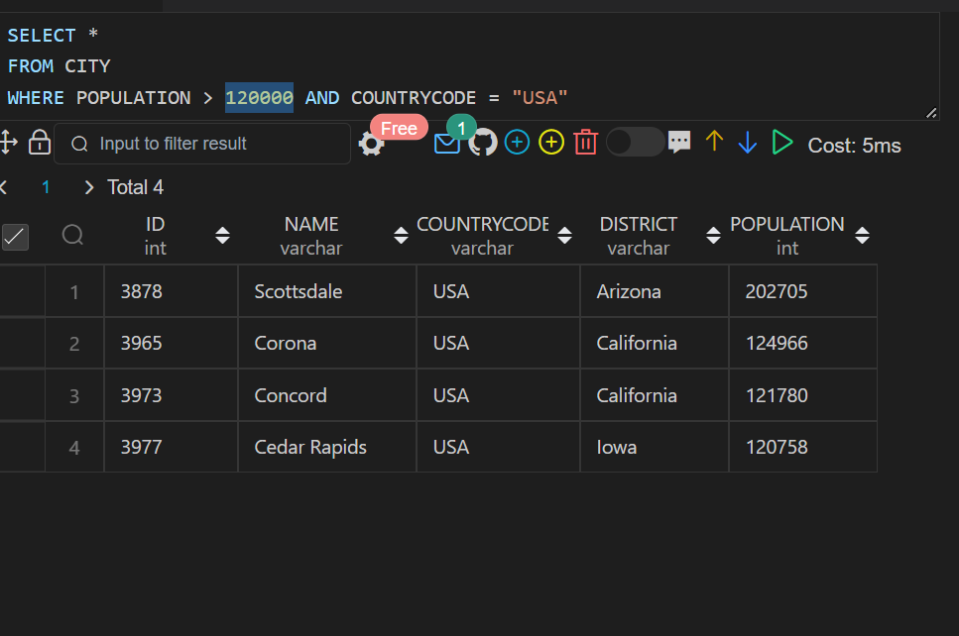

**Q3. Query all columns (attributes) for every row in the CITY table.**

**SQL CODE:**

SELECT * FROM City;

**OUTPUT:**

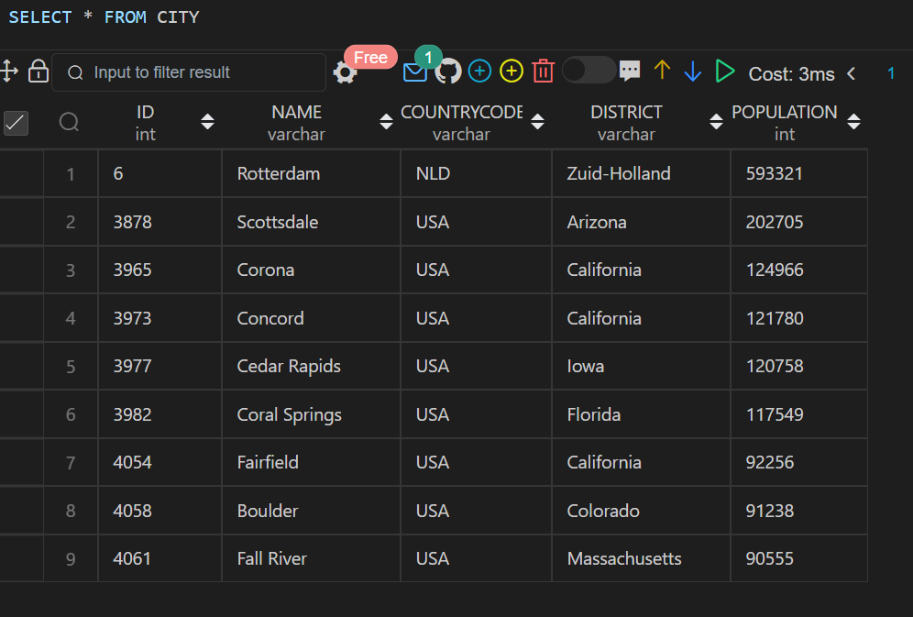

**Q4. Query all columns for a city in CITY with the ID 1661.**

**SQL CODE:**

SELECT * FROM CITY WHERE ID=1661;

**OUTPUT:** 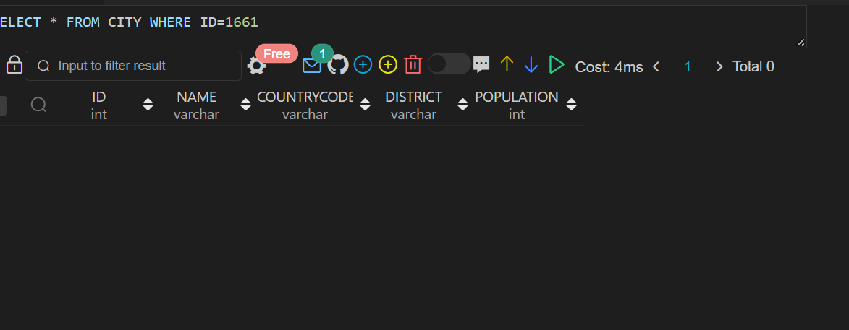

**Q5. Query all attributes of every Japanese city in the CITY table. The COUNTRYCODE for Japan is JPN.**

**Q6. Query the names of all the Japanese cities in the CITY table. The COUNTRYCODE for Japan is JPN.**

**SQL CODE:**

SELECT * FROM CITY WHERE COUNTRYCODE="JPN";

**OUTPUT:**

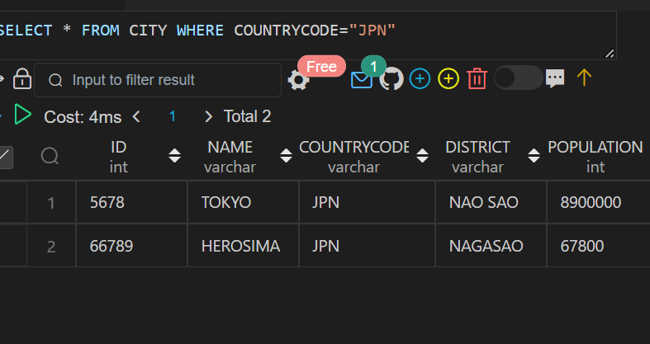

**SQL CODE:**

SELECT Name

FROM CITY WHERE COUNTRYCODE = "JPN";

**OUTPUT:**

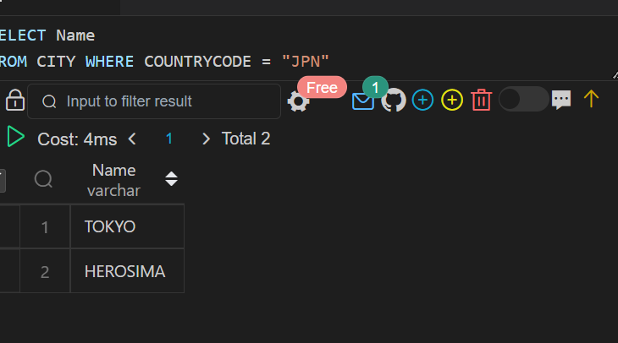

**Sample dataset-2**

**Table creation and value insertion:**

CREATE DATABASE ASSIGNMENT;

USE ASSIGNMENT;

create table  STATION

(

ID integer,

CITY VARCHAR(17),

STATE VARCHAR(3),

LAT_N  integer,

LONG_W integer

);

insert into STATION values(794,'Kissee Mills','MO',139,73),

(824,'Loma Mar','CA',48,130),

(603,'Sandy Hook','CT',72,148),

(478,'Tipton','IN',33,97),

(619,'Arlington','CO',75,92),

(711,'Turner','AR',50,101),

(839,'Slidell','LA',85,151),

(411,'Negreet','LA',98,105),

(588,'Glencoe','KY',46,136),

(665,'Chelsea','IA', 98,59),

(342,'Chignik Lagoon','AK',103,153),

(733,'Pelahatchie','MS',38,28),

(441,'Hanna City','IL',50,136),

(811,'Dorrance','KS',102,121),

(698,'Albany','CA','49',80),

(325,'Monument','KS',70,141),

(414,'Manchester','MD',73,37),

(113,'Prescott','IA',39,65),

(971,'Graettinger','IA',94,150),

(266,'Cahone','CO',116,127);

SELECT * FROM STATION;

**OUTPUT:**

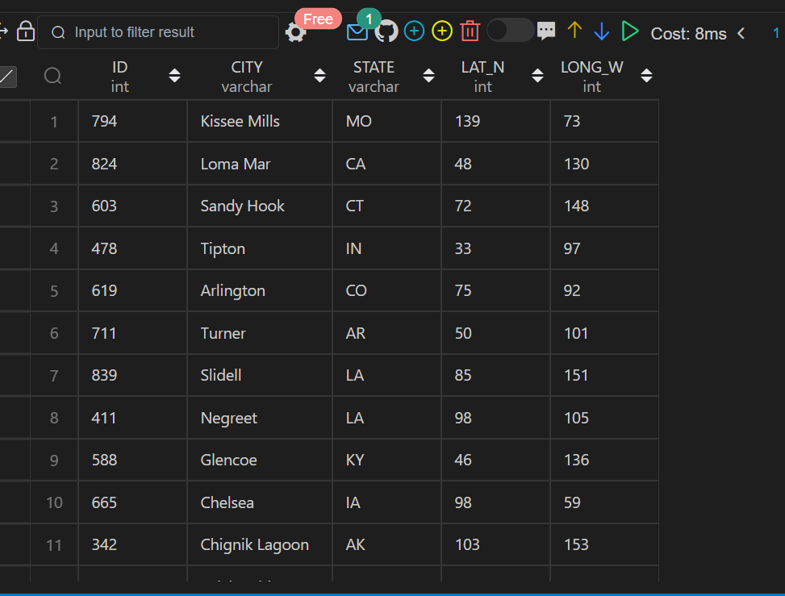

**Q7. Query a list of CITY and STATE from the STATION table.**

**SQL QUERY:**

SELECT CITY, STATE

FROM STATION

ORDER BY CITY, STATE;

**OUTPUT:**

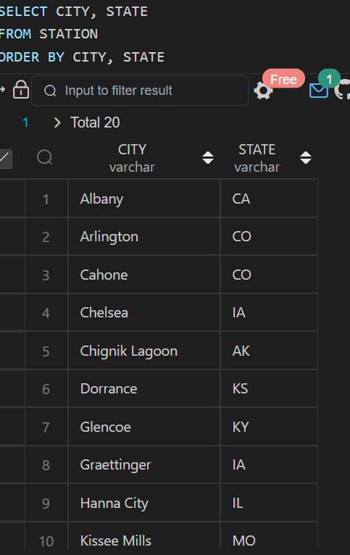

**Q8. Query a list of CITY names from STATION for cities that have an even ID number. Print the results**

**SQL QUERY:**

SELECT DISTINCT CITY

FROM STATION

WHERE (ID % 2) = 0

ORDER BY CITY;

**OUTPUT:**

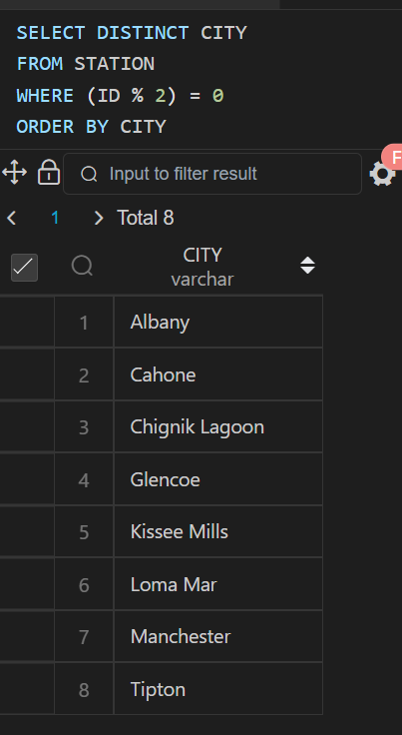

**Q9. Find the difference between the total number of CITY entries in the table and the number of distinct CITY entries in the table**

**SQL QUERY:**

SELECT COUNT(CITY) - COUNT(DISTINCT CITY)

FROM STATION;

**OUTPUT:**

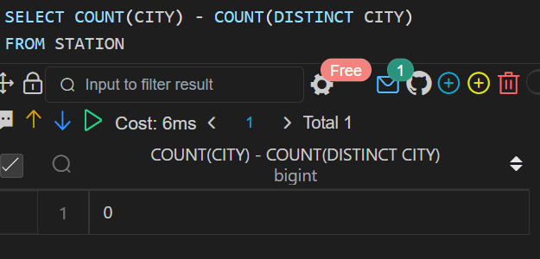

**Q10. Query the two cities in STATION with the shortest and longest CITY names, as well as their respective lengths (i.e.: number of characters in the name). If there is more than one smallest or largest city, choose the one that comes first when ordered alphabetically.**

**SQL QUERY:**

(select CITY, length(CITY) as city_len from STATION order by city_len asc, CITY asc limit 1) union

(select CITY, length(city) as city_len from STATION order by city_len desc, CITY asc limit 1);

**OUTPUT:**

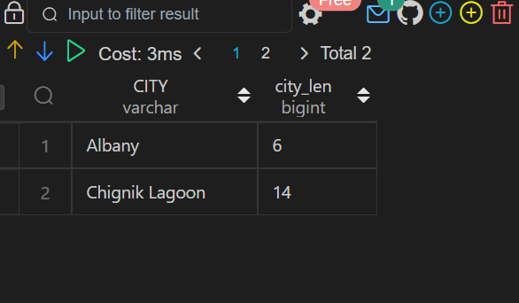

**Q11.Query the list of CITY names starting with vowels (i.e., a, e, i, o, or u) from STATION. Your result cannot contain duplicates.**

**SQL QUERY:**

SELECT  DISTINCT CITY

FROM STATION

WHERE CITY REGEXP'^[aeiouAEIOU]';

**OUTPUT:**

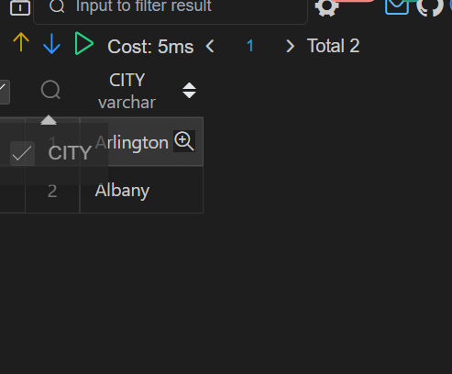

**Q12. Query the list of CITY names ending with vowels (a, e, i, o, u) from STATION. Your result cannot contain duplicates.**

**SQL QUERY:**

SELECT  DISTINCT CITY

FROM STATION

WHERE CITY REGEXP'[aeiouAEIOU]$';

**OUTPUT:**

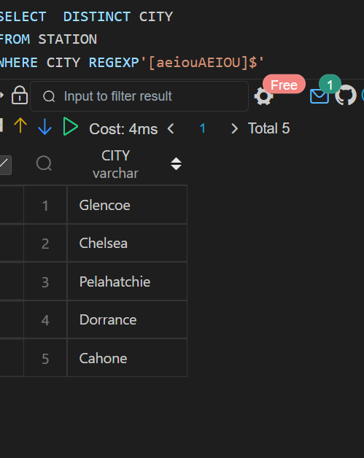

**Q13. Query the list of CITY names from STATION that do not start with vowels. Your result cannot contain duplicates.**

**SQL QUERY:**

SELECT  DISTINCT CITY

FROM STATION

WHERE CITY REGEXP'^[^aeiouAEIOU]';

**OUTPUT:**

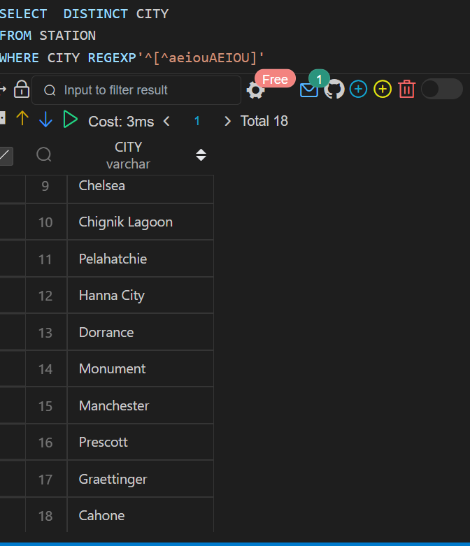

**Q14. Query the list of CITY names from STATION that do not end with vowels. Your result cannot contain duplicates.**

**SQL QUERY:**

SELECT  DISTINCT CITY

FROM STATION

WHERE CITY REGEXP'[^aeiouAEIOU]$';

**OUTPUT:**

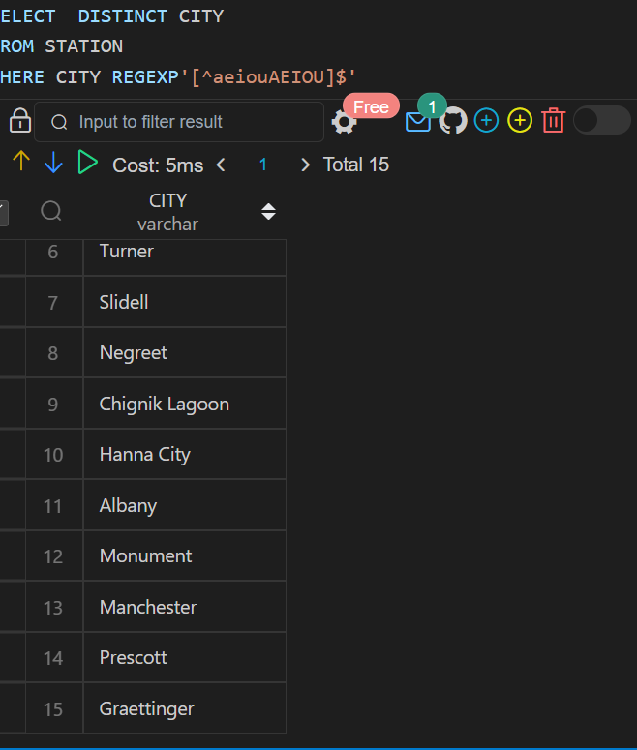

**Q15. Query the list of CITY names from STATION that either do not start with vowels or do not end with vowels. Your result cannot contain duplicates**

**SQL QUERY:**

SELECT DISTINCT(CITY)

FROM STATION

WHERE CITY REGEXP "^[^aeiou].+" OR CITY REGEXP ".+[^aeiou]$"

ORDER BY CITY;

**OUTPUT:**

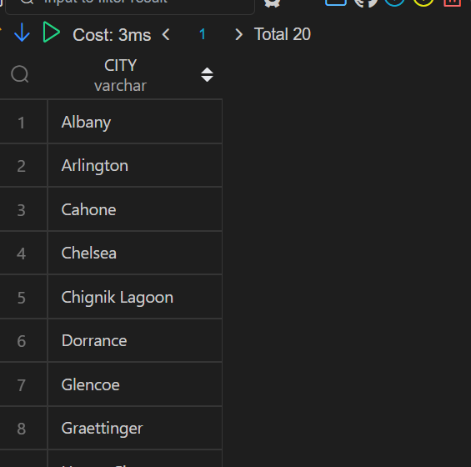

**Q16. Query the list of CITY names from STATION that do not start with vowels and do not end with vowels. Your result cannot contain duplicates.**

**SQL QUERY:**

SELECT DISTINCT CITY

FROM STATION

WHERE CITY REGEXP "^[^AEIOUaeiou].+" AND CITY REGEXP ".+[^aeiou]$"

ORDER BY CITY;

**OUTPUT:**

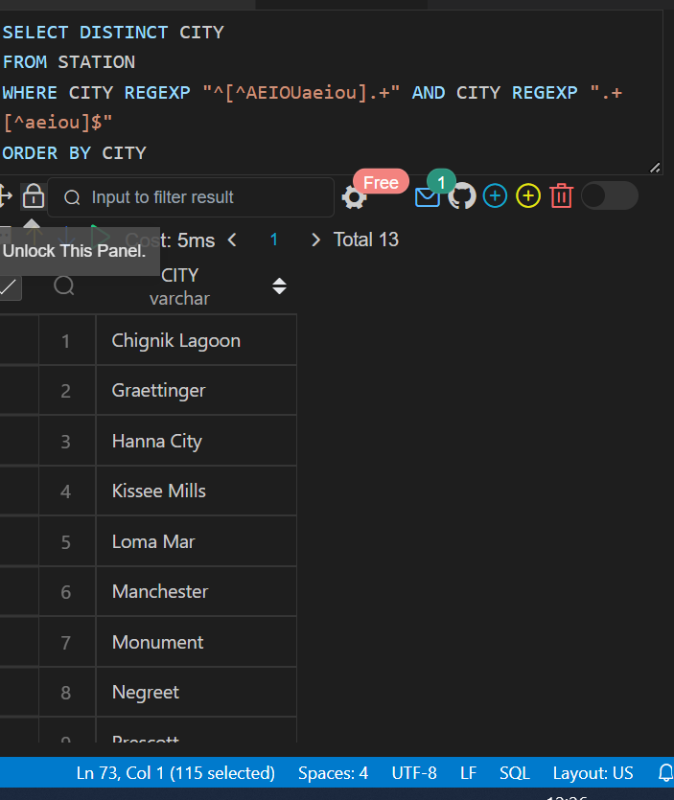

Q17.

CREATE TABLE PRODUCT(

product_id int PRIMARY KEY,

product_name varchar(32),

unit_price int

);

CREATE TABLE SALES(

seller_id int,

product_id int,

buyer_id int,

sale_date date,

quantity int,

price int,

constraint fk Foreign Key (product_id) REFERENCES PRODUCT(product_id)

);

INSERT INTO PRODUCT VALUES(1,'S8',1000),(2,'G4',800),(3,'iPhone',1400);

INSERT INTO SALES VALUES

(1,1,1,'2019-01-21',2,2000),

(1,2,2,'2019-02-17',1,800),

(2,2,3,'2019-06-02',1,800),

(3,3,4,'2019-05-13',2,2800);

**Write an SQL query that reports the products that were only sold in the first quarter of 2019. That is, between 2019-01-01 and 2019-03-31 inclusive.**

**SQL QUERY:**

SELECT product_id,

       product_name

FROM   PRODUCT

WHERE  product_id IN (SELECT product_id

                          FROM   SALES

                          WHERE  sale_date BETWEEN

                                 '2019-01-01' AND '2019-03-31')

**OUTPUT:**

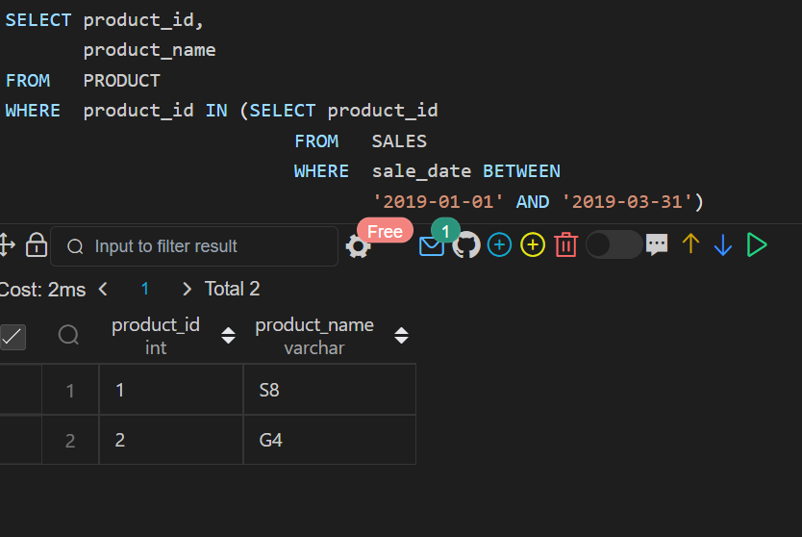

Q18.

create TABLE Views

(article_id int,

author_id int,

viewer_id int,

view_date date

);

INSERT into Views VALUES(1,3,5,'2019-08-01'),

(1,3,6,'2019-08-02'),

(2,7,7,'2019-08-01'),

(2,7,6,'2019-08-02'),

(4,7,1,'2019-07-22'),

(3,4,4,'2019-07-21'),

(3,4,4,'2019-07-21');

**Write an SQL query to find all the authors that viewed at least one of their own articles. Return the result table sorted by id in ascending order**

**SQL QUERY:**

select distinct author_id

from Views

where author_id = viewer_id;

**OUTPUT:**

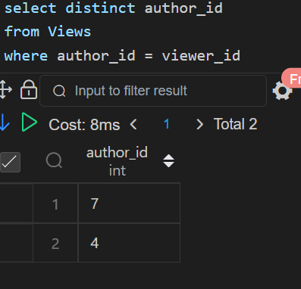

**Q19.**

CREATE  TABLE Delivery(

delivery_id int PRIMARY key,

customer_id int,

order_date date,

customer_pref_delivery_date date

);

INSERT into Delivery VALUES(1,1,'2019-08-01','2019-08-02'),

(2,5,'2019-08-02','2019-08-02'),

(3,1,'2019-08-11','2019-08-11'),

(4,3,'2019-08-24', '2019-08-26'),

(5,4,'2019-08-21', '2019-08-22'),

(6,2,'2019-08-11','2019-08-13');

**Q19.Write an SQL query to find the percentage of immediate orders in the table, rounded to 2 decimal places.**

**SQL QUERY:**

SELECT ROUND(

    SUM( CASE

    WHEN customer_pref_delivery_date=order_date THEN 1 ELSE 0

    END)*100/ COUNT(DISTINCT delivery_id),2)AS immediate_percentage

    FROM Delivery;

**OUTPUT:**

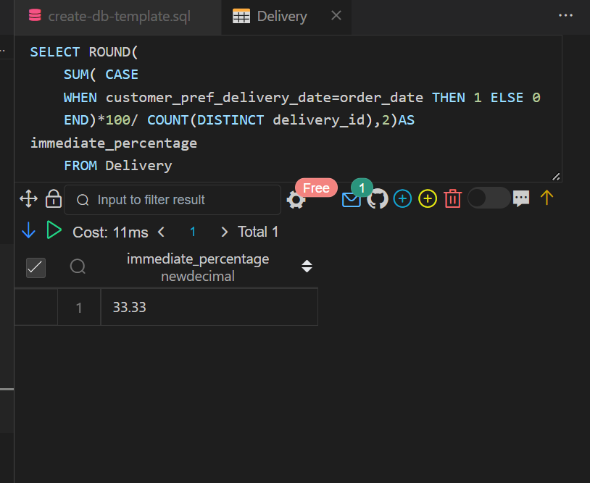

**Q20.**

CREATE TABLE Ads(

ad_id int,

user_id int,

action enum('Clicked','Viewed','Ignored'),

 constraint pk Primary Key(ad_id,user_id)

);

INSERT INTO Ads VALUES(1,1,'Clicked'),

(2,2,'Clicked'),

(3,3,'Viewed'),

(5,5,'Ignored'),

(1,7,'Ignored'),

(2,7,'Viewed'),

(3,5,'Clicked'),

(1,4,'Viewed'),

(2,11,'Viewed'),

(1,2,'Clicked');

**Write an SQL query to find the ctr of each Ad. Round ctr to two decimal points.**

**SQL QUERY:**

select ad_id,

    (case when clicks+views = 0 then 0 else round(clicks/(clicks+views)*100, 2) end) as ctr

from

    (select ad_id,

        sum(case when action='Clicked' then 1 else 0 end) as clicks,

        sum(case when action='Viewed' then 1 else 0 end) as views

    from Ads

    group by ad_id) as t

order by ctr desc, ad_id asc;

**OUTPUT:**

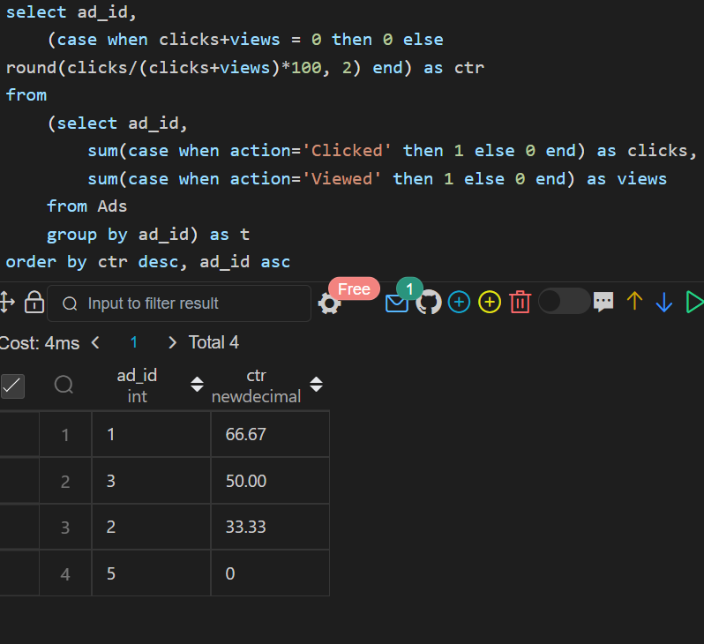

Q21.

CREATE TABLE Employee(

employee_id int,

 team_id INT

);

insert into Employee values(1,8),(2,8),(3,8),(4,7),(5,9),(6,9);

**Write an SQL query to find the team size of each of the employees.**

**SQL QUERY:**

select employee_id, COUNT(team_id) over( partition by team_id) as team_size from Employee ORDER BY employee_id;

**OUTPUT:**

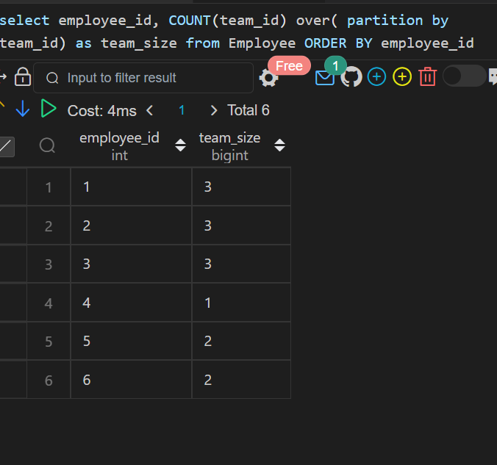

Q22.

CREATE Table Countries(

country_id int PRIMARY key,

country_name varchar(20)

 );

 CREATE Table Weather(

country_id int,

weather_state int,

day date,

CONSTRAINT  PK PRIMARY KEY(country_id, day)

 );

insert into Countries values(2,'USA'),

(3,'Australia'),

(7,'Peru'),

(5,'China'),

(8,'Morocco'),

(9,'Spain');

insert into Weather values(2,15,'2019-11-01'),

(2,12,'2019-10-28'),

(2,12,'2019-10-27'),

(3,-2,'2019-11-10'),

(3,0,'2019-11-11'),

(3,3,'2019-11-12'),

(5,16,'2019-11-07'),

(5,18,'2019-11-09'),

(5,21,'2019-11-23'),

(7,25,'2019-11-28'),

(7,22,'2019-12-01'),

(7,20,'2019-12-02'),

(8,25,'2019-11-05'),

(8,27,'2019-11-15'),

(8,31,'2019-11-25'),

(9,7,'2019-10-23'),

(9,3,'2019-12-23');

Q22)**Write an SQL query to find the type of weather in each country for November 2019.**

**SQL QUERY:**

select country_name, case when avg(weather_state) <= 15 then "Cold"

                          when avg(weather_state) >= 25 then "Hot"

                          else "Warm" end as weather_type

from Countries inner join Weather

on Countries.country_id = Weather.country_id

where left(day, 7) = '2019-11'

group by country_name

**OUTPUT:**

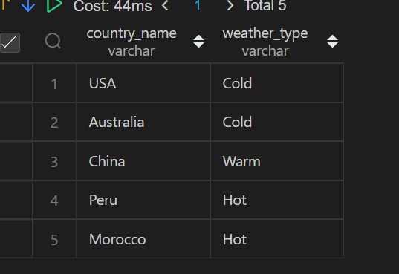

**Q23.**

**Q24.**

CREATE TABLE Activity(

player_id int,

device_id int,

event_date date,

games_played int

);

INSERT INTO Activity VALUES(1,2,'2016-03-01',5),(1,2,'2016-05-02',6),(2,3,'2017-06-25',1),

(3,1,'2016-03-02',0),(3,4,'2018-07-03',5);

**Write an SQL query to report the first login date for each player.**

**SQL QUERY:**

select player_id, min(event_date) as first_login

from Activity

group by player_id;

**OUTPUT:**

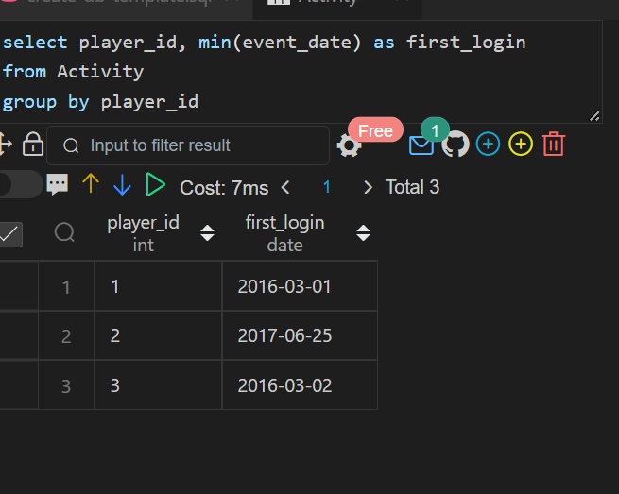

Q25.

**Write an SQL query to report the device that is first logged in for each player**

**SQL QUERY:**

 SELECT player_id, device_id  FROM (SELECT

        player_id,

        device_id,

        event_date,

        MIN(event_date) OVER(PARTITION BY player_id ORDER BY event_date) as first_login

     FROM Activity

) T WHERE event_date=first_login;

**OUTPUT:**

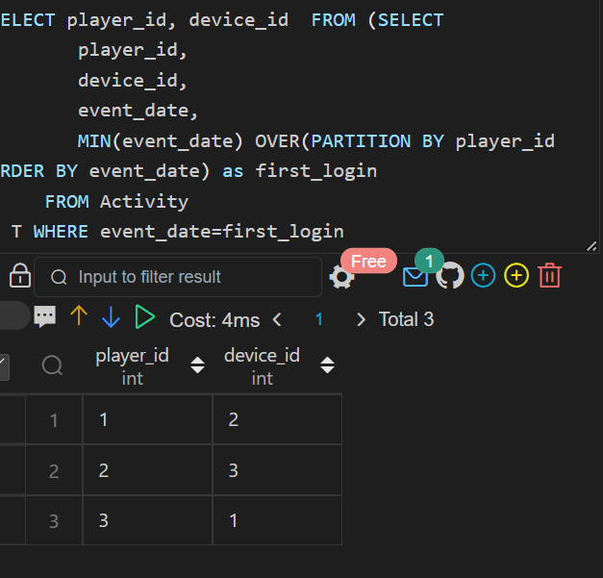

**Q26**

CREATE TABLE  Products(

product_id int,

product_name varchar(29),

product_category varchar(19)

);

CREATE TABLE ORDERS(

product_id int,

order_date date,

unit int

);

INSERT INTO Products VALUES(1,'Leetcode Solutions','Book'),(2,'Jewels of Stringology',' Book'),

(3,'HP','Laptop'),

(4,'Lenovo','Laptop'),

(5,'Leetcode Kit','T-shir');

INSERT INTO ORDERS VALUES(1,'2020-02-05',60),

(1,'2020-02-10', 70),

(2,'2020-01-18',30),

(2,'2020-02-11',80),

(3,'2020-02-17',2),

(3,'2020-02-24',3),

(4,'2020-03-01',20),

(4,'2020-03-04',30),

(4,'2020-03-04',60),

(5,'2020-02-25',50),

(5,'2020-02-27',50),

(5,'2020-03-01',50);

**Write an SQL query to get the names of products that have at least 100 units ordered in February 2020**

**SQL QUERY:**

select p.product_name as product_name, o.sum_unit as unit from Products p

join

(select product_id, sum(unit) as sum_unit from ORDERS  where order_date >= '2020-02-01' and order_date < '2020-03-01'

group by product_id) o

on p.product_id = o.product_id

where o.sum_unit >= 100;

**OUTPUT:**

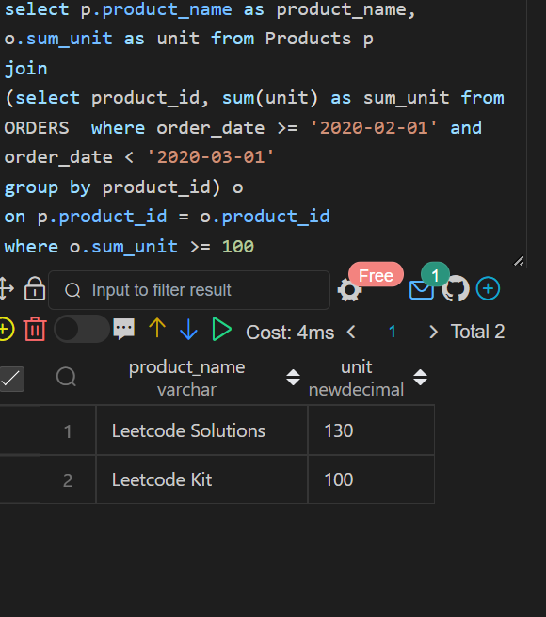

**Q27.**

CREATE TABLE Users(

user_id int,

name varchar(33),

mail varchar(42)

);

insert into Users VALUES(1,'Winston','winston@leetcode.com'),

(2,'Jonathan','jonathanisgreat'),

(3,'Annabelle','bella-@leetcode.com'),

(4,'Sally','sally.come@leetcode.com'),

(5,'Marwan','quarz#2020@leetcode.com'),

(6,'David','david69@gmail.com'),

(7,'Shapiro','.shapo@leetcode.com');

**Write an SQL query to find the users who have valid emails.**

**SQL QUERY:**

SELECT * from Users WHERE mail REGEXP '^[a-zA-z]+[a-zA-Z0-9_\\./\\-]{0,}@leetcode.com$'

ORDER BY user_id;

**OUTPUT:**

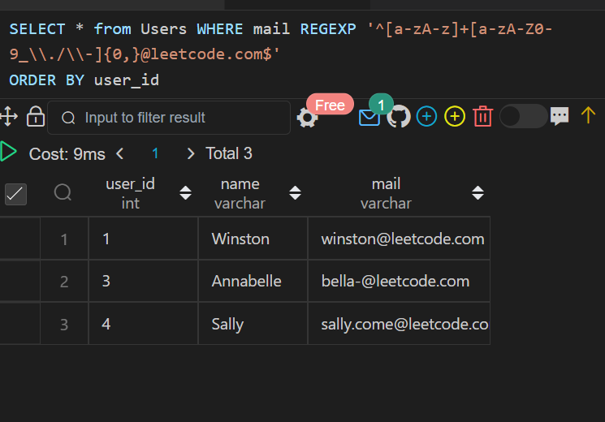

**Q28)**

CREATE TABLE Customers(

customer_id int,

name varchar(33),

country varchar(33)

);

DROP TABLE Product;

CREATE TABLE Product(

product_id int PRIMARY KEY,

name varchar(33),

price int

);

CREATE TABLE ORDERSS(

order_id int PRIMARY KEY,

customer_id int,

product_id int,

order_date date,

quantity int

);

INSERT INTO Customers VALUES(1,'Winston','USA'),(2,'Jonathan','Peru'),

(3,'Moustafa','Egypt');

INSERT INTO Product VALUES(10,'LC Phone', 300),

(20,'LC T-Shirt',10),

(30,'LC Book',45),

(40,'LC Keychain',22);

INSERT INTO ORDERSS VALUES(1,1,10,'2020-06-10',1),

(2,1,20,'2020-07-01',1),

(3,1,30,'2020-07-08', 2),

(4,2,10,'2020-06-15',2),

(5,2,40,'2020-07-01',10),

(6,3,20,'2020-06-24',2),

(7,3,30,'2020-06-25', 2),

(9,3,30,'2020-05-08',3);

**Write an SQL query to report the customer_id and customer_name of customers who have spent at least $100 in each month of June and July 2020.**

**SQL QUERY:**

select o.customer_id, c.name

from

ORDERSS  o

join

Product p

on o.product_id = p.product_id

join

Customers c

on o.customer_id = c.customer_id

group by 1, 2

having sum(case when date_format(order_date, '%Y-%m')='2020-06'

then price*quantity end) >= 100

and

sum(case when date_format(order_date, '%Y-%m')='2020-07'

then price*quantity end) >= 100

**OUTPUT:**

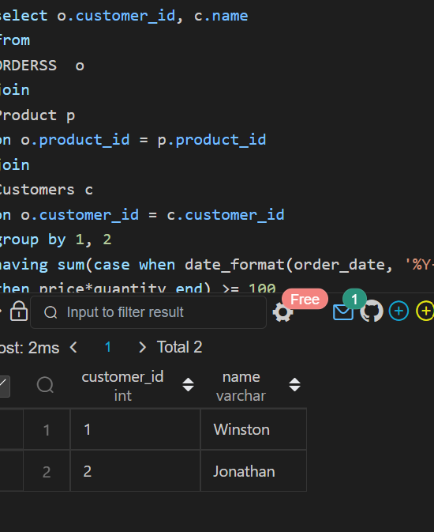

**Q29)**

CREATE TABLE TV(

program_date date,

content_id int,

channel varchar(30),

CONSTRAINT PRIMARY KEY(program_date,content_id )

);

CREATE TABLE Content(

content_id varchar(30) PRIMARY KEY,

title varchar(30),

Kids_content enum('Y','N'),

content_type varchar(30)

);

INSERT INTO TV VALUES('2020-06-10 08:00',1,'LC-Channel'),

('2020-05-11 12:00',2,'LC-Channel'),

('2020-05-12 12:00',3,'LC-Channel'),

('2020-05-13 14:00', 4 ,'Disney Ch'),

('2020-06-18 14:00',4,'Disney Ch'),

('2020-07-15 16:00',5,'Disney Ch');

INSERT INTO Content VALUES

(1,'Leetcode Movie', 'N','Movies'),

(2, 'Alg for Kids', 'Y','Series'),

(3,'Database Sols','N','Series'),

(4,'Aladdin','Y','Movies'),

(5,'Cinderella','Y','Movies');

**Write an SQL query to report the distinct titles of the kid-friendly movies streamed in June 2020. Return the result table in any order**

**SQL QUERY:**

SELECT DISTINCT title

FROM Content ctt

INNER JOIN TV t

ON ctt.content_id = t.content_id

WHERE content_type = 'Movies'

AND Kids_content = 'Y'

AND program_date BETWEEN '2020-06-01' AND '2020-06-30';

**OUTPUT:**

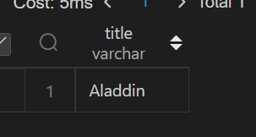

**Q30.**

CREATE TABLE NPV(

id int,

year int,

npv int,

 constraint primary key(id, year)

);

CREATE TABLE Queries(

id int,

year int,

constraint primary key(id, year)

);

insert into NPV VALUES (1,2018,100),

(7,2020,30),

(13, 2019, 40),

(1 ,2019 ,113),

(2 ,2008 ,121),

(3, 2009 ,12),

(11,2020,99),

(7,2019,0);

INSERT INTO Queries VALUES(1 ,2019),

(2,2008),

(3,2009),

(7,2018),

(7,2019),

(7,2020),

(13,2019);

**Write an SQL query to find the npv of each query of the Queries table**

**SQL QUERY:**

select q.id, q.year, ifnull(n.npv,0) as npv

from Queries as q

left join NPV as n

on q.id = n.id AND  q.year = n.year;

**OUTPUT:**

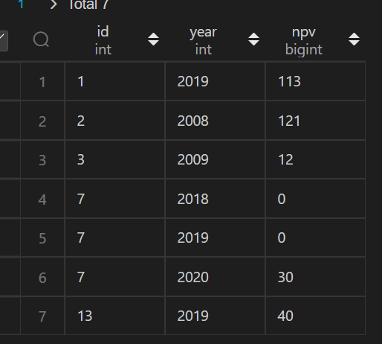

**Q31.**

CREATE TABLE NPV(

id int,

year int,

npv int,

 constraint primary key(id, year)

);

CREATE TABLE Queries(

id int,

year int,

constraint primary key(id, year)

);

insert into NPV VALUES (1,2018,100),

(7,2020,30),

(13, 2019, 40),

(1 ,2019 ,113),

(2 ,2008 ,121),

(3, 2009 ,12),

(11,2020,99),

(7,2019,0);

INSERT INTO Queries VALUES(1 ,2019),

(2,2008),

(3,2009),

(7,2018),

(7,2019),

(7,2020),

(13,2019);

**Write an SQL query to find the npv of each query of the Queries table**

**SQL QUERY:**

select q.id, q.year, ifnull(n.npv,0) as npv

from Queries as q

left join NPV as n

on q.id = n.id AND  q.year = n.year;

**OUTPUT:**



**Q32.**

create TABLE Employees(

id int PRIMARY  KEY,

name varchar(40)

 );

  create TABLE EmployeeUNI(

id int,

unique_id int,

 constraint PRIMARY KEY(id, unique_id)

);

INSERT INTO Employees VALUES(1,'Alice'),

(7, 'Bob'),

(11, 'Meir'),

(90,'Winston'),

(3,'Jonathan');

INSERT INTO EmployeeUNI VALUES(3,1),

(11, 2),

(90,3);

**Write an SQL query to show the unique ID of each user, If a user does not have a unique ID replace just show null.**

**SQL QUERY:**

select unique_id, name

from Employees left join EmployeeUNI

on Employees.id = EmployeeUNI.id

**OUTPUT:**

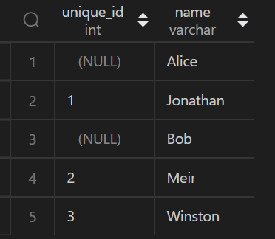

**Q33)**

CREATE TABLE Users(

id int PRIMARY KEY,

name varchar(30)

);

CREATE TABLE Rides(

id int PRIMARY KEY,

user_id int,

distance int

);

insert into Users VALUES(1,'Alice'),

(2,'Bob'),

(3,'Alex'),

(4,'Donald'),

(7,'Lee'),

(13,'Jonathan'),

(19,'Elvis');

insert into Rides VALUES

(1,1,120),

(2,2,317),

(3,3,222),

(4,7,100),

(5,13,312),

(6,19,50),

(7,7,120),

(8,19,400),

(9,7,230);

**Write an SQL query to report the distance travelled by each user. Return the result table ordered by travelled_distance in descending order, if two or more users travelled the same distance, order them by their name in ascending order.**

**SQL QUERY:**

select name, sum(ifnull(distance, 0)) as travelled_distance

from Rides r

right join Users u

on r.user_id = u.id

group by name

order by 2 desc,1 asc;

**OUTPUT:**

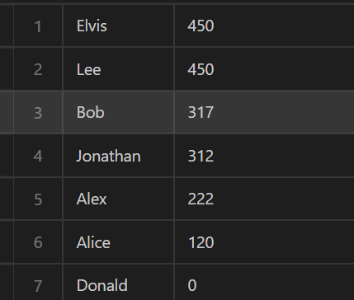

**Q34)**

create TABLE Products(

product_id int PRIMARY KEY,

product_name varchar(30),

product_category varchar(30)

 );

  create TABLE Orders(product_id int,

order_date date,

unit int);

INSERT INTO Products VALUES(1,'Leetcode Solutions','Book'),(2,

'Jewels of Stringology', 'Book'),

(3,'HP','Laptop'),

(4,'Lenovo','Laptop'),

(5,'Leetcode Kit','T-shirt');

INSERT INTO Orders VALUES (1,'2020-02-05',60),

(1,'2020-02-10',70),

(2,'2020-01-18',30),

(2,'2020-02-11',80),

(3,'2020-02-17',2),

(3,'2020-02-24',3),

(4,'2020-03-01',20),

(4,'2020-03-04',30),

(4,'2020-03-04',60);

**Write an SQL query to get the names of products that have at least 100 units ordered in February 2020 and their amount.**

**SQL QUERY:**

select product_name, sum(unit) as unit

from Products inner join Orders

on Products.product_id = Orders.product_id

where left(order_date, 7) = "2020-02"

group by Products.product_id

having sum(unit)>=100;

**OUTPUT:**

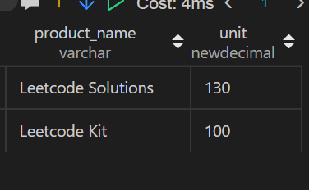

**Q35**

**SQL QUERY:**

 create TABLE Movies(

movie_id int PRIMARY KEY,

title varchar(30)

  );

 create TABLE Users(

user_id int PRIMARY KEY,

name varchar(40)

 );

 create TABLE MovieRating(

movie_id int,

user_id int,

rating int,

created_at date

 );

 INSERT INTO Movies VALUES(1,'Avengers'),

(2,'Frozen 2'),

(3,'Joker');

 INSERT INTO Users VALUES(1,'Daniel'),

(2,'Monica'),

(3,'Maria'),

(4,'James');

 INSERT INTO MovieRating VALUES(1, 1, 3 ,'2020-01-12'),

(1 ,2 ,4, '2020-02-11'),

(1 ,3 ,2, '2020-02-12'),

(1 ,4 ,1 ,'2020-01-01'),

(2 ,1 ,5, '2020-02-17'),

(2 ,2, 2,'2020-02-01'),

(2,3,2,'2020-03-01'),

(3, 1, 3,'2020-02-22'),

(3,2,4,'2020-02-25');

SELECT user_name AS results FROM

(

SELECT a.name AS user_name, COUNT(*) AS counts FROM MovieRating AS b

    JOIN Users AS a

    on a.user_id = b.user_id

    GROUP BY b.user_id

    ORDER BY counts DESC, user_name ASC LIMIT 1

) first_query

UNION

SELECT movie_name AS results FROM

(

SELECT c.title AS movie_name, AVG(d.rating) AS rate FROM MovieRating AS d

    JOIN Movies AS c

    on c.movie_id = d.movie_id

    WHERE substr(d.created_at, 1, 7) = '2020-02'

    GROUP BY d.movie_id

    ORDER BY rate DESC, movie_name ASC LIMIT 1

) second_query;

**OUTPUT:** 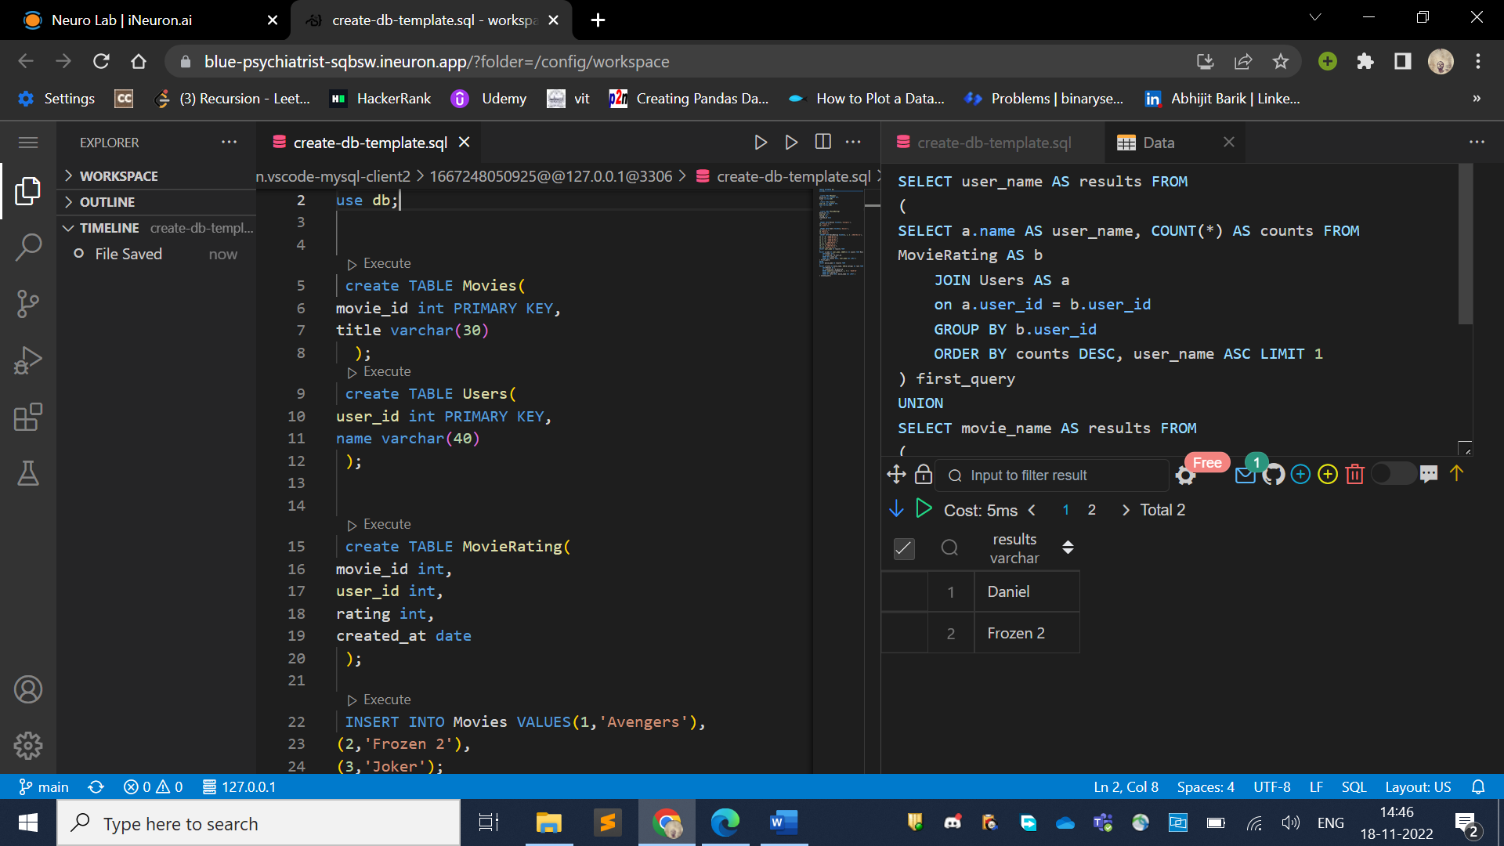

**Q36)**

CREATE TABLE Users(

id int PRIMARY KEY,

name varchar(30)

);

CREATE TABLE Rides(

id int PRIMARY KEY,

user_id int,

distance int

);

insert into Users VALUES(1,'Alice'),

(2,'Bob'),

(3,'Alex'),

(4,'Donald'),

(7,'Lee'),

(13,'Jonathan'),

(19,'Elvis');

insert into Rides VALUES

(1,1,120),

(2,2,317),

(3,3,222),

(4,7,100),

(5,13,312),

(6,19,50),

(7,7,120),

(8,19,400),

(9,7,230);

**Write an SQL query to report the distance travelled by each user. Return the result table ordered by travelled_distance in descending order, if two or more users travelled the same distance, order them by their name in ascending order.**

**SQL QUERY:**

select name, sum(ifnull(distance, 0)) as travelled_distance

from Rides r

right join Users u

on r.user_id = u.id

group by name

order by 2 desc,1 asc;

**OUTPUT:**



**Q37)**

create TABLE Employees(

id int PRIMARY  KEY,

name varchar(40)

 );

  create TABLE EmployeeUNI(

id int,

unique_id int,

 constraint PRIMARY KEY(id, unique_id)

);

INSERT INTO Employees VALUES(1,'Alice'),

(7, 'Bob'),

(11, 'Meir'),

(90,'Winston'),

(3,'Jonathan');

INSERT INTO EmployeeUNI VALUES(3,1),

(11, 2),

(90,3);

**Write an SQL query to show the unique ID of each user, If a user does not have a unique ID replace just show null.**

**SQL QUERY:**

select unique_id, name

from Employees left join EmployeeUNI

on Employees.id = EmployeeUNI.id

**OUTPUT:**



**Q38.**

CREATE TABLE  Departments(

id int PRIMARY KEY,

name varchar(30)

);

CREATE TABLE Students(

id int PRIMARY KEY,

name varchar(30),

department_id int

);

INSERT INTO  Departments VALUES(1,'Electrical Engineering'),

(7,'Computer Engineering'),

(13,'Business Administration');

INSERT INTO Students VALUES(23,'Alice',1),

(1,'Bob',7),

(5,'Jennifer',13),

(2,'John',14),

(4,'Jasmine',77),

(3,'Steve',74),

(6,'Luis',1),

(8,'Jonathan',7),

(7,'Daiana',33),

(11,'Madelynn',1);

**Write an SQL query to find the id and the name of all students who are enrolled in departments that no longer exist.**

**SQL QUERY:**

select s.id, s.name

from Students s

left join Departments d

on s.department_id = d.id

where d.id is null;

--Other way

SELECT id, name

FROM Students

WHERE department_id not in (SELECT id from Departments);

**OUTPUT:**

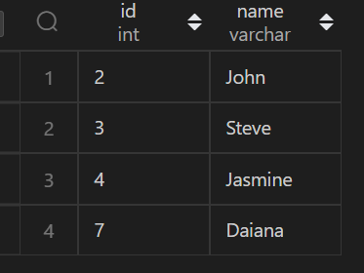

**Q39.**

 CREATE TABLE Calls(

from_id int,

to_id int,

duration int

 );

 INSERT INTO Calls VALUES(1,2,59),

(2,1,11),

(1,3,20),

(3,4,100),

(3,4,200),

(3,4,200),

(4,3,499);

**Write an SQL query to report the number of calls and the total call duration between each pair of distinct persons (person1, person2) where person1 < person2**

**SQL QUERY:**

SELECT LEAST(from_id,to_id) as person1, Greatest(from_id,to_id) as person2,COUNT(*),sum(duration) from Calls group by person1,person2;

**OUTPUT:**

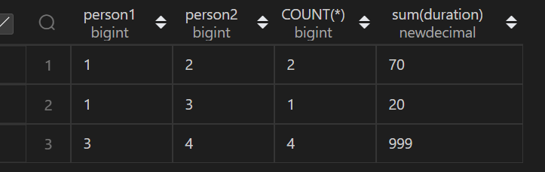

**Q40.**

CREATE TABLE Pricess(

product_id int,

start_date date,

end_date date,

price int,

constraint pk PRIMARY key (product_id,start_date,end_date)

);

CREATE TABLE  UnitsSold(

product_id int,

purchase_date date,

units int

);

insert into Pricess VALUES(1,'2019-02-17','2019-02-28',5),

(1,'2019-03-01','2019-03-22',20),

(2,'2019-02-01','2019-02-20',15),

(2,'2019-02-21','2019-03-31',30);

INSERT INTO UnitsSold VALUES(1,'2019-02-25',100),

(1,'2019-03-01',15),

(2,'2019-02-10',200),

(2,'2019-03-22',30);

**Write an SQL query to find the average selling price for each product. average_price should be rounded to 2 decimal places**

**SQL QUERY:**

select p.product_id, round(sum(p.price*u.units)/sum(u.units) ,2) as avg_price

from Pricess p INNER JOIN UnitsSold u on p.product_id=u.product_id where u.purchase_date  BETWEEN p.start_date and p.end_date GROUP BY p.product_id ;

**OUTPUT:**

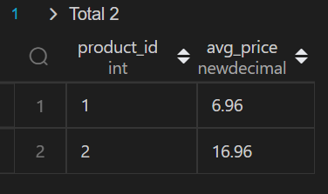

**Q41.**

CREATE TABLE Warehouse(

name varchar(128),

product_id int,

units int,

CONSTRAINT PK PRIMARY KEY(name,product_id)

);

CREATE TABLE Products(

product_id int PRIMARY KEY,

product_name varchar(128),

Width int,

Length int,

Height int

);

INSERT INTO Warehouse VALUES ('LCHouse1',1,1),

('LCHouse1',2,10),

('LCHouse1',3,5),

('LCHouse2', 1,2),

('LCHouse2',2,2),

('LCHouse3',4,1);

INSERT INTO Products VALUES(1 ,'LC-TV', 5 ,50, 40),

(2, 'LC-KeyChain', 5, 5, 5),

(3,'LC-Phone', 2, 10 ,10),

(4 ,'LC-T-Shirt',4,10 ,20);

**Write an SQL query to report the number of cubic feet of volume the inventory occupies in each warehouse.**

**SQL QUERY:**

select warehouse_name, sum(volume) as volume from (

    select w.name as warehouse_name, w.product_id, w.units * Width * Length * Height as volume

    from Warehouse w INNER join Products p on w.product_id = p.product_id

) t group by warehouse_name;

**OUTPUT:**

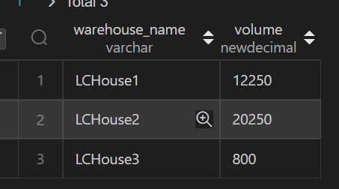

**Q42.**

CREATE Table Sales(

sale_date date,

fruit enum("apples","oranges"),

sold_num int,

CONSTRAINT PK PRIMARY KEY(sale_date, fruit)

);

INSERT INTO Sales VALUES ('2020-05-01','apples', 10),

('2020-05-01', 'oranges',8),

('2020-05-02','apples', 15),

('2020-05-02','oranges',15),

('2020-05-03','apples',20),

('2020-05-03', 'oranges',0),

('2020-05-04','apples',15),

('2020-05-04','oranges',16);

**Write an SQL query to report the difference between the number of apples and oranges sold each day. Return the result table ordered by sale_date.**

**SQL QUERY:**

SELECT sale_date, SUM(CASE WHEN fruit='apples' THEN sold_num

                           WHEN fruit='oranges' THEN -sold_num end ) AS DIFF

 FROM Sales GROUP BY sale_date ;

**OUTPUT:**

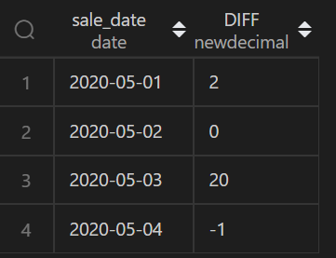

**Q43**

CREATE TABLE Activity(

player_id int,

device_id int,

event_date date,

games_played int,

CONSTRAINT PK PRIMARY KEY(player_id, event_date)

 );

 INSERT INTO Activity VALUES(1,2,'2016-03-01',5),

(1,2,'2016-03-02',6),

(2,3,'2017-06-25',1),

(3,1,'2016-03-02',0),

(3,4,'2018-07-03',5);

**Write an SQL query to report the fraction of players that logged in again on the day after the day they first logged in, rounded to 2 decimal places.**

**SQL QUERY:**

select  round(count(cte.player_id)/(select count(distinct player_id) from Activity) ,2)as fraction

from (SELECT player_id,min(event_date) as start_date from Activity GROUP BY player_id) as cte  inner join Activity a

on cte.player_id=a.player_id  and datediff(cte.start_date,a.event_date)=-1;

**OUTPUT:**

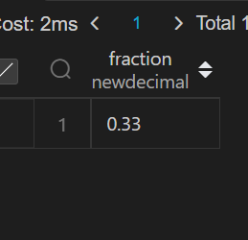

**Q44.**

create TABLE Employee(

id int PRIMARY key,

name varchar(30),

department varchar(30),

managerId int

 );

INSERT into Employee VALUES(101,'John','A',null),

(102,'Dan','A',101),

(103,'James','A',101),

(104,'Amy','A',101),

(105, 'Anne','A', 101),

(106,'Ron','B', 101);

**Write an SQL query to report the managers with at least five direct reports.**

**SQL QUERY:**

select Name From  Employee WHERE Id in( select managerId FROM Employee GROUP BY managerId HAVING  COUNT(*) >=5);

**OUTPUT:**

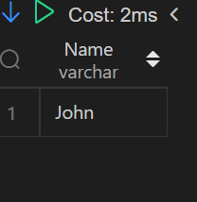

**Q45.**

create TABLE Student(

student_id int,

student_name varchar(30),

gender varchar(30),

dept_id int,

constraint  PRIMARY KEY(student_id),

constraint  Foreign Key(dept_id) REFERENCES Department(dept_id)

);

CREATE TABLE  Department(

dept_id int PRIMARY KEY,

dept_name varchar(30)

);

INSERT INTO Student values(1,'Jack','M',1),

(2,'Jane','F',1),

(3,'Mark','M',2);

INSERT INTO Department VALUES(1,'Engineering'),

(2,'Science'),

(3,'Law');

**Write an SQL query to report the respective department name and number of students majoring in each department for all departments in the Department table**

**SQL QUERY:**

SELECT

    d.DEPT_NAME,

    COUNT(s.STUDENT_ID)

FROM

    Department d

    LEFT JOIN Student s ON d.dept_id = s.dept_id

GROUP by

    d.dept_id

ORDER by

    COUNT(s.STUDENT_ID) DESC,

    d.DEPT_NAME ASC

**OUTPUT:**

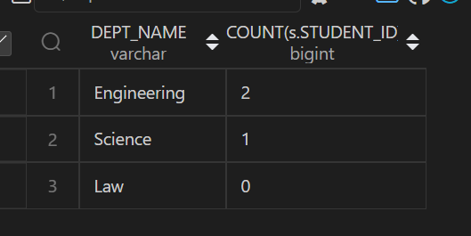

**Q46.**

create table Customer(

customer_id int,

product_key int,

constraint Foreign Key(product_key) REFERENCES Product(product_key)

);

create table Product(

product_key int PRIMARY KEY

);

INSERT INTO  Customer  VALUES( 1,5),

(2,6),

(3,5),

(3,6),

(1,6);

INSERT INTO  Product VALUES(5),(6);

**Write an SQL query to report the customer ids from the Customer table that bought all the products in the Product table**

**SQL QUERY:**

SELECT

    customer_id

FROM Customer

GROUP BY customer_id

HAVING COUNT( DISTINCT product_key) = (SELECT COUNT(*) FROM Product)

**OUTPUT:**

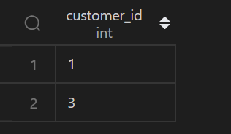

**Q47**

CREATE TABLE Project(

project_id int,

employee_id int,

constraint pk PRIMARY KEY(project_id, employee_id),

constraint fk FOREIGN KEY(employee_id) REFERENCES (employee_id)

);

CREATE TABLE Employees(

employee_id int PRIMARY KEY,

name varchar(40),

experience_years int

);

INSERT INTO  Project VALUES(1,1),

(1,2),

(1,3),

(2,1),

(2,4);

INSERT INTO Employees VALUES(1,'Khaled',3),

(2,'Ali',2),

(3,'John',3),

(4,'Doe',2);

**Write an SQL query that reports the most experienced employees in each project. In case of a tie, report all employees with the maximum number of experience years**

**SQL QUERY:**

SELECT project_id ,employee_id from (SELECT p.project_id ,p.employee_id, dense_rank()  over(partition by p.project_id order by E.experience_years desc ) as rank1

FROM Project p INNER JOIN Employees E on p.employee_id=E.employee_id) temp where rank1=1;

**OUTPUT:**

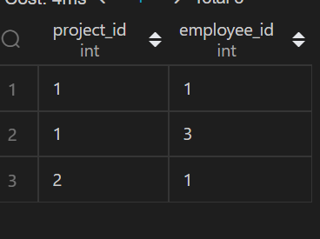

**Q48.**

create table Books(

book_id int PRIMARY KEY,

name varchar(30),

available_from date

);

CREATE TABLE Orders(

order_id int PRIMARY KEY,

book_id int,

quantity int,

dispatch_date date,

CONSTRAINT FK FOREIGN KEY(book_id)REFERENCES Books(book_id)

);

INSERT INTO Books VALUES(1,"Kalila And Demna",'2010-01-01'),

(2 ,"28 Letters",'2012-05-12'),(3,"The Hobbit",'2019-06-10'),

(4 ,"13 Reasons Why",'2019-06-01'),(5,"The Hunger Games",'2008-09-21' );

INSERT INTO Orders VALUES(1,1,2,'2018-07-26'),(2,1,1,'2018-11-05'),(3,3,8,'2019-06-11'),

(4,4,6,'2019-06-05'),

(5,4,5,'2019-06-20'),

(6,5,9,'2009-02-02'),

(7,5,8,'2010-04-13');

**Write an SQL query that reports the books that have sold less than 10 copies in the last year, excluding books that have been available for less than one month from today. Assume today is 2019-06-23. Data of this question is missing, for full data visit** [**https://code.dennyzhang.com/unpopular-books**](https://code.dennyzhang.com/unpopular-books)

**SQL QUERY:**

select book_id, name

from Books

where book_id not in (select book_id from Orders where dispatch_date >='2018-06-23' and dispatch_date <= '2019-06-22' GROUP BY book_id  having sum(quantity) >=10) and available_from < '2019-05-23';

**OUTPUT:  
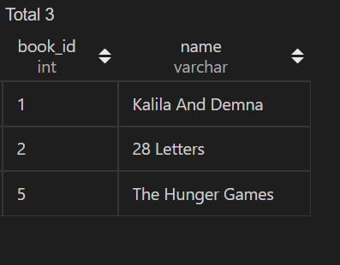**

**Q49.**

CREATE TABLE Enrollments(

student_id int,

course_id int,

grade int,

CONSTRAINT PK PRIMARY KEY(student_id, course_id)

);

INSERT INTO Enrollments(2,2,95),

(2,3,95),

(1,1,90),

(1,2,99),

(3,1,80),

(3,2,75),

(3,3,82);

**Write a SQL query to find the highest grade with its corresponding course for each student. In case of a tie, you should find the course with the smallest course_id.**

**SQL QUERY:**

select student_id, min(course_id) as course_id, grade

from Enrollments

where (student_id, grade) in

    (select student_id, max(grade)

    from Enrollments

    group by student_id)

group by student_id,grade

order by student_id asc

**OUTPUT:**

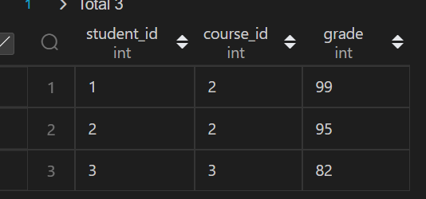

**Q50**

CREATE TABLE Players(

player_id int PRIMARY KEY,

group_id varchar(30)

);

 CREATE TABLE Matches(

match_id int primary KEY,

first_player int,

second_player int,

first_score int,

second_score int

 );

 insert into Players VALUES(15,1),

(25,1),

(30,1),

(45,1),

(10,2),

(35,2),

(50,2),

(20,3),

(40,3);

insert into Matches VALUES(1,15,45,3,0),

(2,30,25,1,2),(3,30,25,1,2),

(4,40,20,5,2),(5,35,50,1,1);

**The winner in each group is the player who scored the maximum total points within the group. In the case of a tie, the lowest player_id wins. Write an SQL query to find the winner in each group.**

**Query:**

select group_id,player_id

from (

    select sc.group_id group_id, sc.player_id player_id,

       rank() over (partition by sc.group_id order by sum(sc.score) desc, sc.player_id asc) as rnk

    from(

        select p.group_id group_id,

         p.player_id player_id ,

         sum(m.first_score) as score

        from Players p

        inner join Matches m

        on p.player_id = m.first_player

        group by p.group_id,p.player_id

        union all

        select p.group_id group_id,

         p.player_id player_id ,

        sum(second_score) as score

        from Players p

        inner join Matches m

        on p.player_id = m.second_player

        group by p.group_id,p.player_id

    ) sc

    group by sc.group_id,sc.player_id

) A

where rnk = 1;

**OUTPUT:**

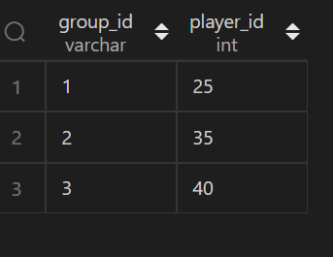

**Q51.**

create TABLE world(

name varchar(30) PRIMARY KEY,

continent varchar(30),

area bigint,

population bigint,

gdp bigint

);

**Write an SQL query to report the name, population, and area of the big countries. Return the result table in any order**

**Query:**

SELECT name,population,area FROM  world where

area >=3000000 or population >= 25000000;

**OUTPUT:**

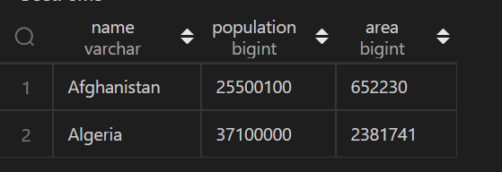

**Q52.**

CREATE TABLE customer(

id int PRIMARY KEY,

name varchar(30),

referee_id int

);

insert into customer values(1, "Will", null);

 insert into customer values(2, "Jane", null);

 insert into customer values(3, "Alex", 2);

  insert into customer values(4, "Bill", null);

   insert into customer values(5, "Zack", 1);

   insert into customer values(6, "Mark", 2);

**Write an SQL query to report the names of the customer that are not referred by the customer with id = 2.**

**Query:**

select name FROM customer where referee_id !=2 or referee_id  is null ;

**OUTPUT:**

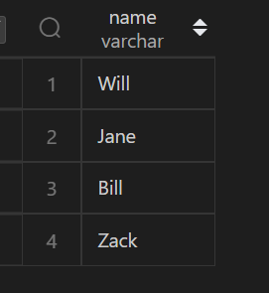

**Q53.**

create TABLE Customers(

id int PRIMARY KEY,

name varchar(30)

  );

insert into Customers values(1,"Joe"),(2, "Henry"),(3, "Sam"),(4,"Max");

 create TABLE Orders(

id int PRIMARY KEY,

customerId INT

 );

 insert  into Orders VALUES(1, 3),(2, 1);

**Write an SQL query to report all customers who never order anything. Return the result table in any order**

**Query:**

SELECT name from Customers where id not in( select customerId  from Orders );

**OUTPUT:**

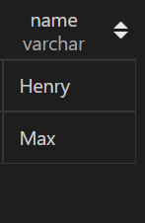

**Q54.**

create table Employee(

employee_id int,

team_id int

 );

 INSERT INTO Employee values(1,8),

(2,8),(3,8),

(4,7),

(5,9),

(6,9);

**Write an SQL query to find the team size of each of the employees.**

**Query:**

SELECT employee_id,count(*) over( partition by team_id ) as team_size FROM  Employee ORDER BY employee_id ;

**OUTPUT:**

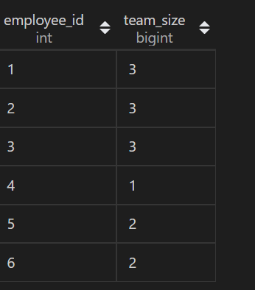

**Q55**

CREATE TABLE person(

id int PRIMARY KEY,

name varchar(30),

phone_number varchar(30)

);

 CREATE TABLE country(

name varchar(30),

country_code varchar(30) PRIMARY KEY

 );

  CREATE TABLE calls(

 caller_id int,

callee_id int,

duration int

  );

insert into person values(3 , "Jonathan", "051-1234567"),(12, "Elvis", "051-7654321"),(1 , "Moncef", "212-1234567"),

(2 , "Maroua", "212-6523651"),(7 , "Meir", "972-1234567"),(9 , "Rachel", "972-0011100");

insert into country  values("Peru", '051'),("Israel", '972'),("Morocco", '212'),("Germany", '049'),("Ethiopia", '251');

insert into calls values (1, 9, 33),(2, 9, 4),(1, 2, 59),(3, 12, 102),(3, 12, 330),(12, 3, 5),(7, 9, 13),(7, 1, 3),(9, 7, 1),(1, 7, 7);

**Write an SQL query to find the countries where this company can invest. Return the result table in any order**

**Query:**

SELECT cc.name from person p inner join  calls c on p.id=c.caller_id or p.id=c.callee_id

 inner join country cc on cc.country_code=left(p.phone_number,3) group by cc.name having avg(c.duration) >

(select avg(duration) from calls);

**OUTPUT:**

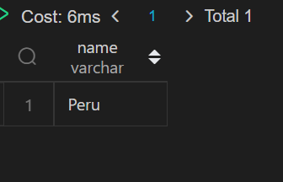

**Q56.**

CREATE TABLE Activity(

player_id int,

device_id int,

event_date date,

games_played int

);

INSERT INTO Activity VALUES(1,2,'2016-03-01',5),(1,2,'2016-05-02',6),(2,3,'2017-06-25',1),

(3,1,'2016-03-02',0),(3,4,'2018-07-03',5);

**Write an SQL query to report the first login date for each player.**

**SQL QUERY:**

select player_id, min(event_date) as first_login

from Activity

group by player_id;

**OUTPUT:**



**Q57.**

reate table Orders(

order_number int PRIMARY key,

customer_number int

);

INSERT into Orders VALUES(1,1),(2,2),(3,3),(4,3);

**Write an SQL query to find the customer_number for the customer who has placed the largest number of orders.**

**SQL QUERY:**

select

 a.customer_number

from

 (select customer_number, count(order_number) order_count

  from Orders group by customer_number) a

order by a.order_count desc limit 1;

**OUTPUT:**

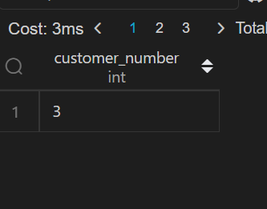

**Q58.**

CREATE TABLE  Cinema(

seat_id int  PRIMARY KEY AUTO_INCREMENT,

free bool

);

INSERT INTO Cinema VALUES(1,1),

(2,0),

(3,1),

(4,1),

(5,1);

**Write an SQL query to report all the consecutive available seats in the cinema.**

**SQL QUERY:**

SELECT distinct c1.seat_id from Cinema c1 INNER JOIN Cinema  c2 on

(c1.seat_id = c2.seat_id+1) or (c1.seat_id=c2.seat_id-1) WHERE c1.free=1 and c1.free=c2.free order by c1.seat_id asc;

**OUTPUT:**

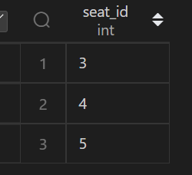

**Q59.**

create TABLE SalesPerson(

sales_id int PRIMARY KEY,

name varchar(30),

salary int,

commission_rate int,

hire_date date

);

CREATE  table Company(

com_id int PRIMARY KEY,

name varchar(30),

city varchar(30)

);

create Table Orders(

order_id int PRIMARY KEY,

order_date date,

com_id int,

sales_id int,

amount int,

constraint  fk FOREIGN KEY(com_id) REFERENCES Company(com_id)

);

insert into SalesPerson values(1, "John",  100000, 6, STR_TO_DATE("4/1/2006","%m/%d/%Y")),(2, "Amy ", 12000, 5,  STR_TO_DATE("5/1/2010","%m/%d/%Y")),(3, "Mark",  65000, 12, STR_TO_DATE("12/25/2008","%m/%d/%Y")),

(4, "Pam ", 25000, 25,  STR_TO_DATE("1/1/2005","%m/%d/%Y")),(5, "Alex",  5000, 10, STR_TO_DATE("2/3/2007" ,"%m/%d/%Y"));

insert into Company values(1, "RED", "Boston"),(2, "ORANGE", "New York"),(3, "YELLOW", "Boston"),(4, "GREEN", "Austin");

insert into Orders values(1, STR_TO_DATE("1/1/2014","%m/%d/%Y"), 3, 4, 10000),(2, STR_TO_DATE("2/1/2014","%m/%d/%Y"), 4, 5, 5000),

(3,STR_TO_DATE("3/1/2014","%m/%d/%Y") , 1, 1, 50000),(4, STR_TO_DATE("4/1/2014","%m/%d/%Y"), 1, 4, 25000);

**Write an SQL query to report the names of all the salespersons who did not have any orders related to the company with the name "RED".**

**Query:**

SELECT name

FROM SalesPerson

WHERE sales_id

NOT IN (

    SELECT s.sales_id FROM Orders o

    INNER JOIN SalesPerson s ON o.sales_id = s.sales_id

    INNER JOIN Company c ON o.com_id = c.com_id

    WHERE c.name = 'RED'

);

**OUTPUT:**

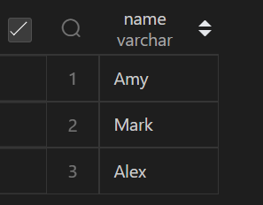

**Q60.**

create DATABASE db;

use db;

create TABLE Triangle (

x int,

y int,

z int,

constraint pk PRIMARY KEY(x,y,z)

);

INSERT INTO Triangle values(13,15,30),(10,20,15);

**Write an SQL query to report for every three line segments whether they can form a triangle.**

**Query:**

SELECT

    x,

    y,

    z,

    IF(x + y > z AND y + z > x AND z + x > y, 'Yes', 'No') triangle

FROM

   Triangle ;

**OUTPUT:**

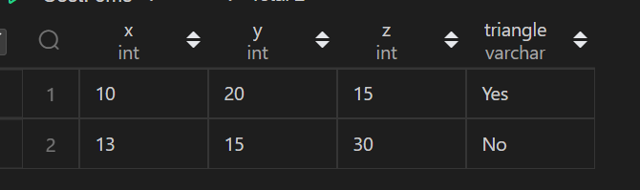

**Q61.**

create table  Point(

x int

);

insert into Point  values (-1),(0),(2);

**Write an SQL query to report the shortest distance between any two points from the Point table. The query result format is in the following example.**

**Query:**

SELECT min( distance ) from (select abs(p1.x -p2.x) as distance from Point p1 cross join Point p2 WHERE p1.x <> p2.x ) tmp;

**OUTPUT:**

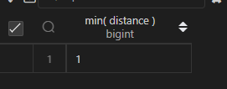

**Q62.**

CREATE TABLE  ActorDirector(

actor_id int,

director_id int,

timestamp int primary key

);

insert into ActorDirector  values(1,1,0),(1,1,1),(1,1,2),(1,2,3),(1,2,4),(2,1,5),(2,1,6);

**Write a SQL query for a report that provides the pairs (actor_id, director_id) where the actor has cooperated with the director at least three times.**

**Query:**

 select actor_id,director_id from (select actor_id, director_id,count(*) as frequent from ActorDirector

 group by actor_id,director_id) temp where temp.frequent >=3;

**OUTPUT:**

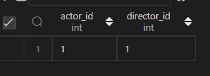

**Q63.**

create Table Sales(

sale_id int,

product_id int,

year int,

quantity int,

price int,

constraint pk primary key(sale_id,year),

constraint fk foreign key(product_id) references Product(product_id)

);

 create table Product(

product_id int primary key,

product_name varchar(30)

);

insert into Product values(100,"Nokia"),(200,"Apple"),(300,"Samsung");

insert into Sales  values(1,100,2008,10,5000),

(2,100,2009,12,5000),

(7,200,2011,15,9000);

**Write an SQL query that reports the product_name, year, and price for each sale_id in the Sales table. Return the resulting table in any order.**

**Query:**

SELECT  product_name,year,price FROM  Product P INNER JOIN Sales S ON P.product_id = S.product_id ;

**OUTPUT:**

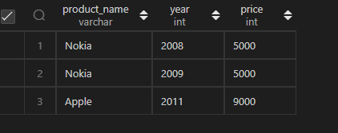

**Q64.**

create Table Project(

project_id int,

employee_id int,

constraint pk primary key(project_id, employee_id)

);

INSERT INTO Project VALUES(1,1),(1,2),(1,3),(2,1),(2,4);

CREATE TABLE Employee(

employee_id int PRIMARY KEY,

name varchar(30),

experience_years int

);

insert into  Employee VALUES(1,'Khaled',3),(2,'Ali',2),(3,'John',1),(4,'Doe',2);

**Write an SQL query that reports the average experience years of all the employees for each project, rounded to 2 digits.**

**Query:**

SELECT  project_id,round(avg(experience_years),2) as avrage_year from Project p inner join  Employee e on p.employee_id =e.employee_id

  group by project_id;

**OUTPUT:**

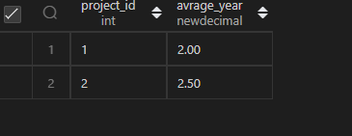

**Q65.**

CREATE Table Sales(

seller_id int,

product_id int,

buyer_id int,

sale_date date,

quantity int,

price int,

constraint fk FOREIGN KEY(product_id) REFERENCES Product(product_id)

);

insert into Product values (1,'S8',1000),(2,'G4',800),(3,'iPhone',1400);

insert into Sales  values (1,1,1,'2019-01-21',2,2000),(1,2,2,'2019-02-17',1,800),(2,2,3,'2019-06-02',1,800),(3,3,4,'2019-05-13',2,2800);

**Write an SQL query that reports the best seller by total sales price, If there is a tie, report them all. Return the result table in any order.**

**Query:**

select seller_id from Sales group by seller_id

    having sum(price)=(select max(price) FROM  Sales );

Another way

select seller_id from (select seller_id, rank() over(order by sum(price) DESC) as rk from Sales group by seller_id)tmp where tmp.rk=1

**OUTPUT:**

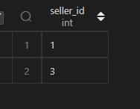

**Q66.**

CREATE Table Product(

product_id int PRIMARY KEY,

product_name varchar(30),

unit_price int

);

CREATE Table Sales(

seller_id int,

product_id int,

buyer_id int,

sale_date date,

quantity int,

price int,

constraint fk FOREIGN KEY(product_id) REFERENCES Product(product_id)

);

insert into Product values (1,'S8',1000),(2,'G4',800),(3,'iPhone',1400);

insert into Sales  values (1,1,1,'2019-01-21',2,2000),(1,2,2,'2019-02-17',1,800),(2,2,3,'2019-06-02',1,800),(3,3,3,'2019-05-13',2,2800);

**Write an SQL query that reports the buyers who have bought S8 but not iPhone. Note that S8 and iPhone are products present in the Product table.**

**Query:**

select s.buyer_id

from Product p

join Sales s

on p.product_id=s.product_id

group by buyer_id

having sum(p.product_name='S8') >=1  and sum(p.product_name = 'iPhone') =0 ;

**OUTPUT:**

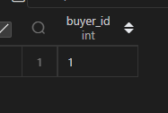

**Q67.**

create Table Customer(

customer_id int,

name varchar(30),

visited_on date,

amount int,

constraint pk PRIMARY KEY(customer_id, visited_on)

);

INSERT INTO Customer VALUES(1,'Jhon','2019-01-01',100),(2,'Daniel','2019-01-02',110),

(3,'Jade','2019-01-03',120),(4,'Khaled','2019-01-04',130),(5,'Winston','2019-01-05',110),

(6,'Elvis','2019-01-06',140),(7,'Anna','2019-01-07',150),(8,'Maria','2019-01-08',80),

(9,'Jaze','2019-01-09',110),(1,'Jhon','2019-01-10',130),(3,'Jade','2019-01-10',150);

**You are the restaurant owner and you want to analyse a possible expansion (there will be at least one customer every day)**

**Query:**

select c1.visited_on, sum(c2.amount) as amount,

    round(avg(c2.amount), 2) as average_amount

from (select visited_on, sum(amount) as amount

      from Customer group by visited_on) c1

join (select visited_on, sum(amount) as amount

      from Customer group by visited_on) c2

on datediff(c1.visited_on, c2.visited_on) between 0 and 6

group by c1.visited_on

having count(c2.amount) = 7 ORDER BY c1.visited_on;

**OUTPUT:**

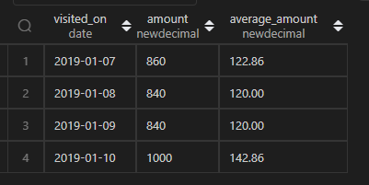

**Q68.**

CREATE TABLE Scores(

player_name varchar(30),

gender varchar(30),

day date,

score_points int,

constraint pk PRIMARY KEY((gender, day)

);

insert into Scores values('Aron','F','2020-01-01', 17),

('Alice','F','2020-01-07',23),

('Bajrang','M','2020-01-07',7),

('Khali','M','2019-12-25',11),

('Slaman','M','2019-12-30', 13),

('Joe','M','2019-12-31', 3),

('Jose','M','2019-12-18',2),

('Priya','F','2019-12-31',23),

('Priyanka','F','2019-12-30',17);

**Write an SQL query to find the total score for each gender on each day.**

**Query:**

select gender,day, sum(score_points) over(partition by gender order by gender,day  rows BETWEEN unbounded preceding and current row) as total from  Scores;

**OUTPUT:**

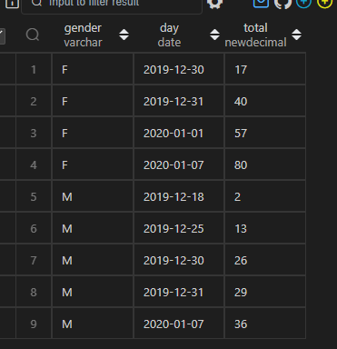

**Q69.**

select gender,day, sum(score_points) over(partition by gender order by gender,day  rows BETWEEN unbounded preceding and current row) as total from  Scores;

create Table Logs(

log_id int

);

insert into Logs VALUES(1),(2),(3),(7),(8),(10);

**Write an SQL query to find the total score for each gender on each day.**

**Query:**

select min(log_id) as start_date ,max(log_id)as end_date from (SELECT log_id,log_id-row_number() over(order by log_id ) as diff from Logs) cte GROUP BY cte.diff ORDER BY start_date;

**OUTPUT:**

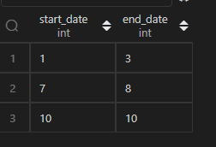

**70)**

CREATE Table Students(

student_id int PRIMARY KEY,

student_name varchar(30)

);

CREATE Table Subjects(

subject_name varchar(30) PRIMARY KEY

);

 CREATE Table Examinations(

student_id int,

subject_name varchar(30)

 );

 INSERT INTO Students VALUES(1,'Alice'),(2,'Bob'),(13,'John'),(6,'Alex');

insert into Subjects VALUES('Math'),('Physics'),('Programming');

INSERT INTO Examinations VALUES (1,'Math'),(1,'Physics'),(1,'Programming'),

(2,'Programming'),(1,'Physics'),(1,'Math'),(13,'Math'),(13,'Programming'),

(13,'Physics'),(2,'Math'),(1,'Math');

**Write an SQL query to find the number of times each student attended each exam.**

**Query:**

select cte1.student_id,cte1.subject_name,

CASE WHEN cnt IS NOT NULL THEN cnt

ELSE 0 END AS attende

 from (SELECT  student_id, subject_name,student_name from  Students cross JOIN Subjects)cte1 left JOIN

(SELECT student_id ,subject_name,count(student_id) as cnt from Examinations GROUP BY student_id ,subject_name)cte2 on cte1.student_id=cte2.student_id and cte1.subject_name=cte2.subject_name

order by cte1.student_id,cte1.subject_name;

**Output:**

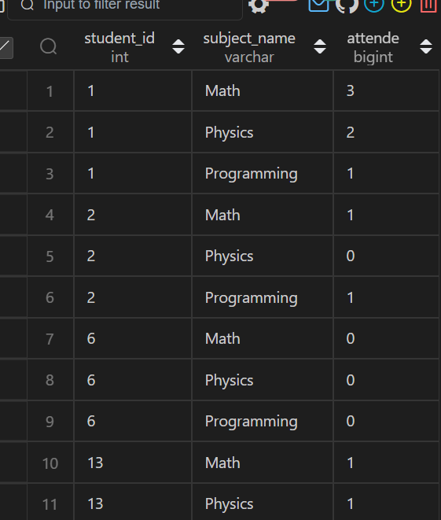

**Q71.**

create  TABLE Employees(

employee_id int ,

employee_name varchar(30),

manager_id int

);

INSERT INTO  Employees VALUES(1,'Boss',1),(3,'Alice',3),

(2,'Bob',1),

(4,'Daniel',2),

(7,'Luis',4),

(8,'Jhon',3),

(9,'Angela',8),

(77,'Robert',1);

**Write an SQL query to find employee_id of all employees that directly or indirectly report their work to the head of the company**

**Query:**

select a.employee_id as EMPLOYEE_ID

from

    Employees as a

    left join

    Employees as b on a.manager_id = b.employee_id

    left join

    Employees as c on b.manager_id = c.employee_id

    left join

    Employees as d on c.manager_id = d.employee_id

where

    a.employee_id != 1

    and

    d.employee_id = 1;

**Output:**

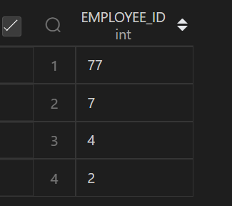

**Q72.**

create Table Transactions(

id int PRIMARY KEY,

country varchar(30),

state enum("approved", "declined"),

amount int,

trans_date date

);

INSERT INTO  Transactions VALUES (121,'US', 'approved',1000,'2018-12-18'),

(122,'US','declined',2000,'2018-12-19'),

(123,'US','approved',2000,'2019-01-01'),

(124,'DE','approved',2000,'2019-01-07');

**Write an SQL query to find for each month and country, the number of transactions and their total amount, the number of approved transactions and their total amount.**

**Query:**

select date_format(trans_date,'%Y-%m') as month,country,count(*) as trans_count,sum(if(state='approved',1,0))as approved_count,sum(amount),

sum(if(state = 'approved', amount, 0)) as approved_total_amount

    from Transactions

GROUP BY date_format(trans_date,'%Y-%m'),country;

**Output:**

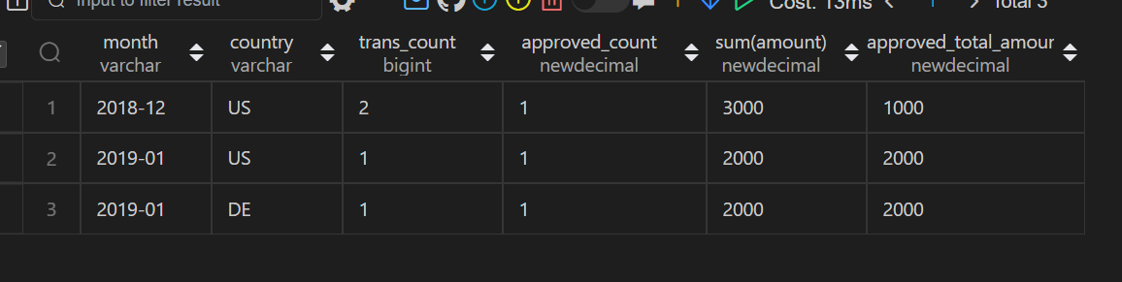

**Q73.**

create Table Actions(

user_id int,

post_id int,

action_date date,

action enum('view', 'like', 'reaction', 'comment', 'report', 'share'),

extra varchar(30)

 );

 create Table Removals(

post_id int,

remove_date date

 );

insert into Actions values(1,1,'2019-07-01', 'view','null'),

(1,1,'2019-07-01','like','null'),

(1,1,'2019-07-01','share','null'),

(2,2,'2019-07-04','view','null'),

(2,2,'2019-07-04','report','spam'),

(3,4,'2019-07-04','view','null'),

(3,4,'2019-07-04','report','spam'),

(4,3,'2019-07-02','view','null'),

(4,3,'2019-07-02','report','spam'),

(5,2,'2019-07-03','view','null'),

(5,2,'2019-07-03','report','racism'),

(5,5,'2019-07-03','view','null'),

(5,5,'2019-07-03','report','racism');

insert into Removals values(2,'2019-07-20'),(3,'2019-07-18');

**Write an SQL query to find the average daily percentage of posts that got removed after being reported as spam, rounded to 2 decimal places.**

**Query:**

select avg(daily_percentage)as average_daily_percent from

(select count(distinct b.post_id)/count(distinct a.post_id)*100 as daily_percentage from  Actions a  left join Removals b  on a.post_id= b.post_id where a.extra='spam' GROUP BY action_date)temp;

**Output:**

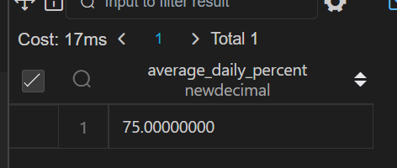

**Q74.**

CREATE TABLE Activity(

player_id int,

device_id int,

event_date date,

games_played int

);

INSERT INTO Activity VALUES(1,2,'2016-03-01',5),(1,2,'2016-05-02',6),(2,3,'2017-06-25',1),

(3,1,'2016-03-02',0),(3,4,'2018-07-03',5);

**Write an SQL query to report the fraction of players that logged in again on the day after the day they first logged in, rounded to 2 decimal places.**

**SQL QUERY:**

select  round(count(cte.player_id)/(select count(distinct player_id) from Activity) ,2)as fraction

from (SELECT player_id,min(event_date) as start_date from Activity GROUP BY player_id) as cte  inner join Activity a

on cte.player_id=a.player_id  and datediff(cte.start_date,a.event_date)=-1;

**OUTPUT:**



**Q75.**

CREATE TABLE Activity(

player_id int,

device_id int,

event_date date,

games_played int

);

INSERT INTO Activity VALUES(1,2,'2016-03-01',5),(1,2,'2016-05-02',6),(2,3,'2017-06-25',1),

(3,1,'2016-03-02',0),(3,4,'2018-07-03',5);

**Write an SQL query to report the fraction of players that logged in again on the day after the day they first logged in, rounded to 2 decimal places.**

**SQL QUERY:**

select  round(count(cte.player_id)/(select count(distinct player_id) from Activity) ,2)as fraction

from (SELECT player_id,min(event_date) as start_date from Activity GROUP BY player_id) as cte  inner join Activity a

on cte.player_id=a.player_id  and datediff(cte.start_date,a.event_date)=-1;

**OUTPUT:**



**Q76.**

create Table Salaries(

company_id int,

employee_id int,

employee_name varchar(30),

salary int,

constraint primary key(company_id, employee_id)

);

insert into Salaries values(1,1,'Tony',2000),

(1,2,'Pronub',21300),

(1,3,'Tyrrox',10800),

(2,1,'Pam',300),

(2,7,'Bassem',450),

(2,9,'Hermione',700),

(3,7,'Bocaben',100),

(3,2,'Ognjen',2200),

(3,13,'Nyan Cat',3300),

(3,15,'Morning Cat',7777);

**Write an SQL query to find the salaries of the employees after applying taxes. Round the salary to the nearest integer.**

**Query:**

select company_id, employee_id, employee_name, round(salary - salary*tax, 0) as salary

from

(

  select *,

  case when max(salary) over(partition by company_id) < 1000 then 0

       when max(salary) over(partition by company_id) between 1000

       and 10000 then 0.24

       else 0.49 end as tax

  from Salaries

) x ;

**Output:**

**Q77.**

CREATE Table Sales(

sale_date date,

fruit enum("apples","oranges"),

sold_num int,

CONSTRAINT PK PRIMARY KEY(sale_date, fruit)

);

INSERT INTO Sales VALUES ('2020-05-01','apples', 10),

('2020-05-01', 'oranges',8),

('2020-05-02','apples', 15),

('2020-05-02','oranges',15),

('2020-05-03','apples',20),

('2020-05-03', 'oranges',0),

('2020-05-04','apples',15),

('2020-05-04','oranges',16);

**Write an SQL query to report the difference between the number of apples and oranges sold each day. Return the result table ordered by sale_date.**

**SQL QUERY:**

SELECT sale_date, SUM(CASE WHEN fruit='apples' THEN sold_num

                           WHEN fruit='oranges' THEN -sold_num end ) AS DIFF

 FROM Sales GROUP BY sale_date ;

**OUTPUT:**

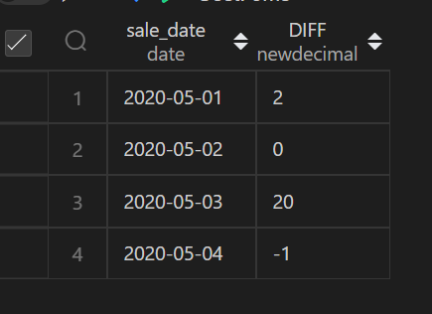

**Q78.**

create Table Variables(

name varchar(30) primary key ,

value int

);

create Table Expressions(

left_operand varchar(30),

operator enum('<', '>', '='),

right_operand varchar(30),

constraint fk primary key(left_operand, operator, right_operand)

);

insert into Variables values('x',66),('y',77);

**Write an SQL query to evaluate the boolean expressions in Expressions table. Return the result table in any order**

**SQL QUERY:**

SELECT e.*,case when operator = '=' and v1.value=v2.value then 'true'

                when operator = '<' and v1.value < v2.value then 'true'

                 when operator = '>' and v1.value > v2.value then 'true'

                else 'false'

                end as value

from Expressions e left join Variables  v1 on e.left_operand = v1.name

left join  Variables v2  on e.right_operand = v2.name;

**OUTPUT:**

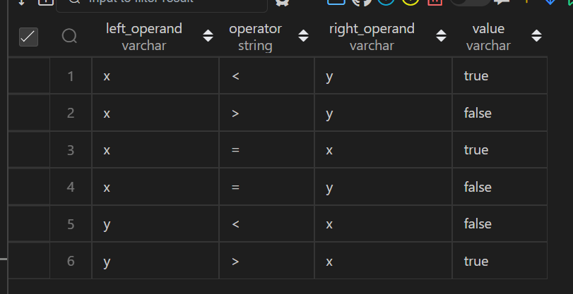

**Q79.**

create Table Movies(

movie_id int  primary key,

title varchar(30)

);

CREATE Table Users(

user_id int primary key,

name varchar(30)

);

create Table MovieRating(

movie_id int,

user_id int,

rating int,

created_at date,

constraint pk PRIMARY KEY(movie_id, user_id)

);

INSERT INTO Movies  VALUES(1,'Avengers'),(2,'Frozen2'),(3,'Joker');

INSERT INTO Users values(1,'Daniel'),(2,'Monica'),(3,'Maria'),(4,'James');

insert into MovieRating values  (1,1,3,'2020-01-12'),

(1,2,4,'2020-02-11'),

(1, 3, 2, '2020-02-12'),

(1, 4, 1,'2020-01-01'),

(2,1,5,'2020-02-17'),

(2,2,2,'2020-02-01'),

(2,3,2,'2020-03-01'),

(3,1,3,'2020-02-22'),

(3,2,4,'2020-02-25');

**Write an SQL query to:**

**● Find the name of the user who has rated the greatest number of movies. In case of a tie, return the lexicographically smaller user name.**

**● Find the movie name with the highest average rating in February 2020. In case of a tie, return the lexicographically smaller movie name**

**Query**

(select name from

 MovieRating m left join Users u  on  m.user_id=u.user_id

  GROUP BY name order by count(*) desc, name LIMIT 1

)

UNION

  (SELECT

    m.title

FROM MovieRating as mr JOIN Movies as m

ON mr.movie_id = m.movie_id

WHERE DATE_FORMAT(created_at, '%Y-%m') = '2020-02'

GROUP BY 1

ORDER BY AVG(rating) DESC, 1

LIMIT 1)

**OUTPUT**

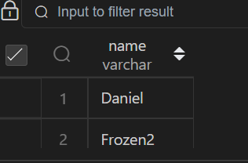

**80)**

CREATE TABLE person(

id int PRIMARY KEY,

name varchar(30),

phone_number varchar(30)

);

 CREATE TABLE country(

name varchar(30),

country_code varchar(30) PRIMARY KEY

 );

  CREATE TABLE calls(

 caller_id int,

callee_id int,

duration int

  );

insert into person values(3 , "Jonathan", "051-1234567"),(12, "Elvis", "051-7654321"),(1 , "Moncef", "212-1234567"),

(2 , "Maroua", "212-6523651"),(7 , "Meir", "972-1234567"),(9 , "Rachel", "972-0011100");

insert into country  values("Peru", '051'),("Israel", '972'),("Morocco", '212'),("Germany", '049'),("Ethiopia", '251');

insert into calls values (1, 9, 33),(2, 9, 4),(1, 2, 59),(3, 12, 102),(3, 12, 330),(12, 3, 5),(7, 9, 13),(7, 1, 3),(9, 7, 1),(1, 7, 7);

**Write an SQL query to find the countries where this company can invest. Return the result table in any order**

**Query:**

SELECT cc.name from person p inner join  calls c on p.id=c.caller_id or p.id=c.callee_id

 inner join country cc on cc.country_code=left(p.phone_number,3) group by cc.name having avg(c.duration) >

(select avg(duration) from calls);

**OUTPUT:**



**Q81.**

CREATE TABLE STUDENTS (

    ID INTEGER,

    NAME VARCHAR(30),

    MARKS VARCHAR(30)

);

insert into STUDENTS  VALUES(1,'Ashley',81),(2,'Samantha',75),(4,'Julia',76),(3,'Belvet',84);

**Query the Name of any student in STUDENTS who scored higher than 75 Marks.**

**Query:**

SELECT name from STUDENTS  where MARKS >75 order by right(name,3);

**OUTPUT:**

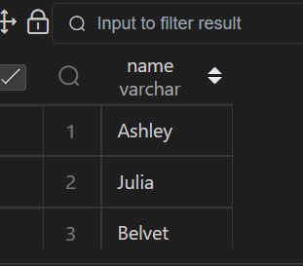

**Q82.**

CREATE TABLE EMPLOYEE(

    employee_id INTEGER,

    name varchar(30),

    months INTEGER,

    salary INTEGER

);

insert into EMPLOYEE VALUES(1228,'Rose',15,1968),(33645,'Angela',1,3443),(45692,'Frank',17,1608),

(56118,'Pratick',7,1345),(59725,'Lisa',11,2330),

(74197,'Kimberly',16,4372);

**Write a query that prints a list of employee names (i.e.: the name attribute) from the Employee table in alphabetical order.**

**Query:**

select * from EMPLOYEE order by name;

**OUTPUT:**

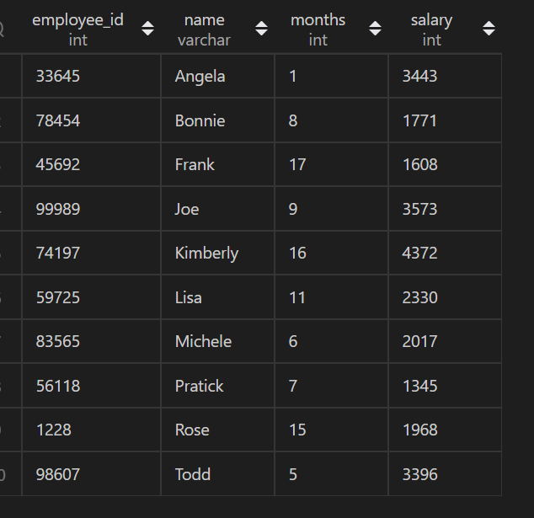

**Q83.**

CREATE TABLE EMPLOYEE(

    employee_id INTEGER,

    name varchar(30),

    months INTEGER,

    salary INTEGER

);

insert into EMPLOYEE VALUES(1228,'Rose',15,1968),(33645,'Angela',1,3443),(45692,'Frank',17,1608),

(56118,'Pratick',7,1345),(59725,'Lisa',11,2330),

(74197,'Kimberly',16,4372),(78454,'Bonnie',8,1771),

(83565,'Michele',6,2017),(98607,'Todd',5,3396),

(99989,'Joe',9,3573);

**Write a query that prints a list of employee names (i.e.: the name attribute) for employees in Employee having a salary greater than $2000 per month who have been employees for less than 10 months. Sort your result by ascending employee_id**.

**Query:**

select * from EMPLOYEE where salary > 2000 and months < 10 order by  employee_id  ;

**OUTPUT:**

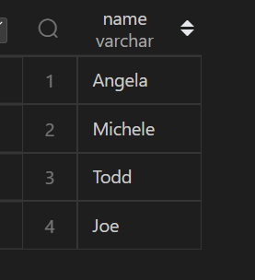

**Q84.**

create table TRIANGLES(

    A integer,

    B integer,

    C integer

);

insert into TRIANGLES VALUES(20,20,23),(20,20,20),(20,21,22),(13,14,30);

Write a query identifying the type of each record in the TRIANGLES table using its three side lengths.

**Query:**

SELECT CASE

WHEN A + B <= C OR A + C <= B OR B + C <= A THEN 'Not A Triangle'

WHEN A = B AND B = C THEN 'Equilateral'

WHEN A = B OR B = C OR A = C THEN 'Isosceles'

ELSE 'Scalene'

END as result

FROM TRIANGLES;

**OUTPUT:**

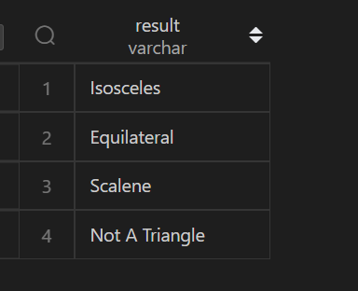

**85)**

create table user_transactions(

transaction_id integer,

product_id integer,

spend decimal,

transaction_date datetime

);

;

insert into user_transactions VALUES(1341,123424,1500.60,STR_TO_DATE("12/31/2019 12:00:00",'%m/%d/%Y %T')),

(1423,123424,1000.20,STR_TO_DATE('12/31/2020 12:00:00','%m/%d/%Y %T')),

(1623,123424,1246.44,STR_TO_DATE('12/31/2021 12:00:00','%m/%d/%Y %T')),

(1322,123424,2145.32,STR_TO_DATE('12/31/2022 12:00:00','%m/%d/%Y %T'));

**Write a query to obtain the year-on-year growth rate for the total spend of each product for each year.**

**Query:**

WITH yearsum AS

(

SELECT EXTRACT(YEAR FROM transaction_date) as year, product_id, SUM(spend) as spend

FROM user_transactions

GROUP BY 1,2

)

SELECT a.year, a.product_id,

a.spend as curr_year_spend,

b.spend as prev_year_spend,

ROUND(100.00*(a.spend - b.spend)/b.spend,2) as yoy_rate

FROM yearsum a

LEFT JOIN yearsum b ON a.year-1=b.year AND a.product_id = b.product_id

ORDER BY 2,1;

**Output:**

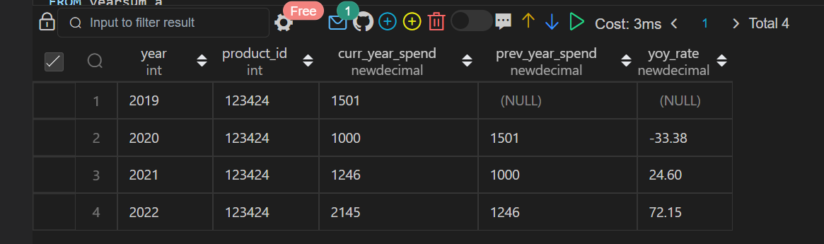

**86)**

 create table inventory(

item_id integer,

item_type varchar(30),

item_category varchar(30),

square_footage decimal

 );

insert into inventory VALUES (1374,'prime_eligible' ,'mini refrigerator',68.00),

(4245,'not_prime standing','lamp',26.40),

(2452,'prime_eligible','television',85.00),

(3255,'not_prime','side table',22.60),

(1672,'prime_eligible','laptop',8.50);

**Write a SQL query to find the number of prime and non-prime items that can be stored in the 500,000 square feet warehouse. Output the item type and number of items to be stocked.**

**Query:**

SELECT item_type,

case

when item_type = 'prime_eligible'

then Floor(500000/sum(square_footage))*count(item_type)

else floor((500000 -(select(floor(500000/sum(square_footage)))*sum(square_footage) from inventory where item_type = 'prime_eligible'))/sum(square_footage))*Count(item_type)

end

from

inventory

group by item_type

order by item_type desc;

**Output:**

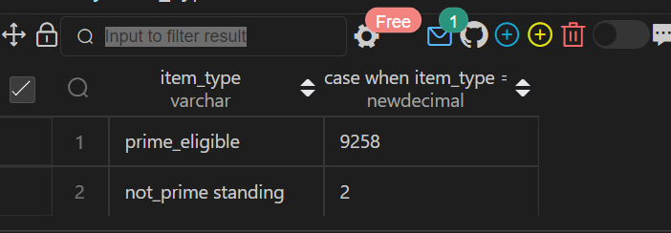

**Q87)**

Create Table user_actions (

users_id int,

event_id int,

event_type varchar(50),

event_date datetime );

nsert into user_actions Values(445, 7765 ,'sign-in',STR_TO_DATE('05/31/2022 12:00:00','%m/%d/%Y %T'));

Insert into user_actions Values(445, 3634 ,'like',STR_TO_DATE('06/05/2022 12:00:00','%m/%d/%Y %T'));

Insert into user_actions Values(742, 6458 ,'sign-in', STR_TO_DATE('07/03/2022 12:00:00','%m/%d/%Y %T'));

Insert into user_actions Values(742, 1374 ,'comment', STR_TO_DATE('07/19/2022 12:00:00','%m/%d/%Y %T'));

**Assume you have the table below containing information on Facebook user actions. Write a query to obtain the active user retention in July 2022. Output the month (in numerical format 1, 2, 3) and the number of monthly active users (MAUs).**

**Query:**

SELECT EXTRACT(MONTH FROM a1.event_date) as month, COUNT(DISTINCT a1.users_id) as monthly_active_users

from user_actions as a1,user_actions as a2

where a1.users_id = a2.users_id AND

EXTRACT(MONTH FROM a1.event_date) = 7

AND EXTRACT(MONTH FROM a2.event_date) =6

AND EXTRACT(YEAR FROM a1.event_date) = 2022

AND EXTRACT(YEAR FROM a2.event_date) =2022

AND a1.event_type in ( 'sign-in', 'like', 'comment') AND

a2.event_type in ('sign-in', 'like', 'comment')

GROUP BY month;

**Output:**

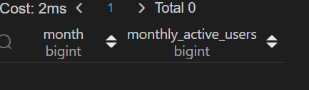

**Q88)**

Google's marketing team is making a Superbowl commercial and needs a simple statistic to put on their TV ad: the median number of searches a person made last year. However, at Google scale, querying the 2 trillion searches is too costly. Luckily, you have access to the summary table which tells you the number of searches made last year and how many Google users fall into that bucket.

Query

WITH expanded AS(

  SELECT searches

  FROM search_frequency

  GROUP BY searches, GENERATE_SERIES(1,num_users)

)

SELECT PERCENTILE_CONT(0.5) WITHIN GROUP (ORDER BY searches) AS median

FROM expanded

**Output**

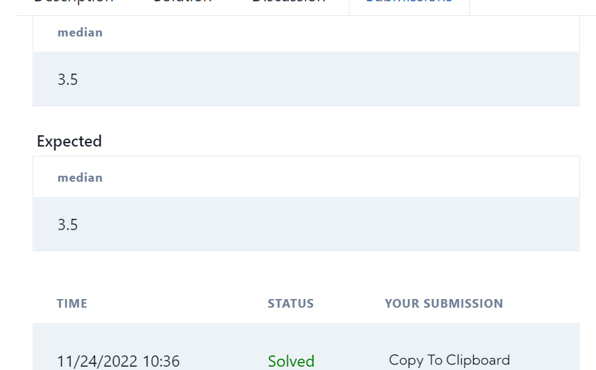

**Q91.**

**Sometimes, payment transactions are repeated by accident; it could be due to user error, API failure or a retry error that causes a credit card to be charged twice. Using the transactions table, identify any payments made at the same merchant with the same credit card for the same amount within 10 minutes of each other. Count such repeated payments. Level - Hard Hint- Use Partition and order by**

Query

select count(t1.merchant_id) as payment_count

from transactions t1

join transactions t2

on t1.merchant_id=t2.merchant_id

and t1.credit_card_id=t2.credit_card_id

and t1.amount=t2.amount

and t1.transaction_id<t2.transaction_id

where (date_part('minute',t2.transaction_timestamp)-date_part('minute',t1.transaction_timestamp))<=10

and  date_part('hour',t1.transaction_timestamp)=date_part('hour',t2.transaction_timestamp)

;;

**OUTPUT**

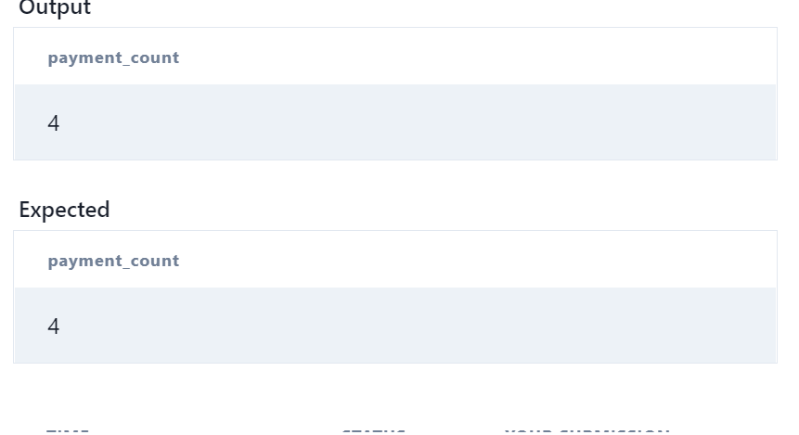

create Table Scores(

player_name varchar(30),

gender varchar(30),

day date,

score_points int,

 constraint pk PRIMARY key(gender, day)

);

insert into Scores VALUES('Aron','F','2020-01-01',17),

('Alice','F','2020-01-07',23),

('Bajrang','M','2020-01-07',7),

('Khali','M','2019-12-25',11),

('Slaman','M','2019-12-30',13),

('Joe','M','2019-12-31',3),

('Jose','M','2019-12-18',2),

('Priya','F','2019-12-31',23),

('Priyanka','F','2019-12-30',1);

**Write an SQL query to find the total score for each gender on each day. Return the result table ordered by gender and day in ascending order.**

**Query**

select s.gender, s.day, (select sum(score_points) from Scores where gender = s.gender and day <= s.day) as total

    from Scores s

    group by gender, day

    order by gender, day;

**Output:**

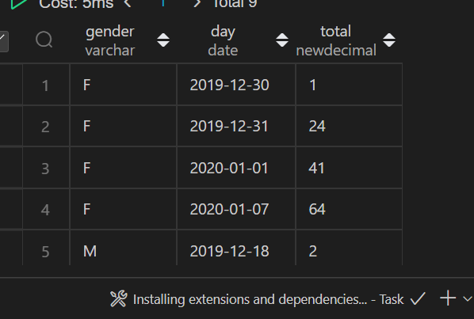

**Q94.**

CREATE TABLE person(

id int PRIMARY KEY,

name varchar(30),

phone_number varchar(30)

);

 CREATE TABLE country(

name varchar(30),

country_code varchar(30) PRIMARY KEY

 );

  CREATE TABLE calls(

 caller_id int,

callee_id int,

duration int

  );

insert into person values(3 , "Jonathan", "051-1234567"),(12, "Elvis", "051-7654321"),(1 , "Moncef", "212-1234567"),

(2 , "Maroua", "212-6523651"),(7 , "Meir", "972-1234567"),(9 , "Rachel", "972-0011100");

insert into country  values("Peru", '051'),("Israel", '972'),("Morocco", '212'),("Germany", '049'),("Ethiopia", '251');

insert into calls values (1, 9, 33),(2, 9, 4),(1, 2, 59),(3, 12, 102),(3, 12, 330),(12, 3, 5),(7, 9, 13),(7, 1, 3),(9, 7, 1),(1, 7, 7);

**Write an SQL query to find the countries where this company can invest. Return the result table in any order**

**Query:**

SELECT cc.name from person p inner join  calls c on p.id=c.caller_id or p.id=c.callee_id

 inner join country cc on cc.country_code=left(p.phone_number,3) group by cc.name having avg(c.duration) >

(select avg(duration) from calls);

**OUTPUT:**



Q95.

Create table If Not Exists Numbers (

       Number int,

       Frequency int);

insert into Numbers (Number, Frequency) values ('0', '7');

insert into Numbers (Number, Frequency) values ('1', '1');

insert into Numbers (Number, Frequency) values ('2', '3');

insert into Numbers (Number, Frequency) values ('3', '1');

**Write an SQL query to report the median of all the numbers in the database after decompressing the Numbers table. Round the median to one decimal point**.

**Query:**

select

    avg(number) median

from

   Numbers n

where

    n.frequency >= abs(

                        (select sum(Frequency) from Numbers where Number<=n.number)

                        -

                        (select sum(Frequency) from Numbers where Number>=n.number));

**OUTPUT:**



**Q96**

Create table If Not Exists salary (

    id int,

    employee_id int,

    amount int,

    pay_date date);

Create table If Not Exists employee (

    employee_id int,

    department_id int);

Truncate table salary;

insert into salary

    (id, employee_id, amount, pay_date)

values

    ('1', '1', '9000', '2017/03/31');

insert into salary

    (id, employee_id, amount, pay_date)

values

    ('2', '2', '6000', '2017/03/31');

insert into salary

    (id, employee_id, amount, pay_date)

values

    ('3', '3', '10000', '2017/03/31');

insert into salary

    (id, employee_id, amount, pay_date)

values

    ('4', '1', '7000', '2017/02/28');

insert into salary

    (id, employee_id, amount, pay_date)

values

    ('5', '2', '6000', '2017/02/28');

insert into salary

    (id, employee_id, amount, pay_date)

values

    ('6', '3', '8000', '2017/02/28');

Truncate table employee;

insert into employee

    (employee_id, department_id)

values

    ('1', '1');

insert into employee

    (employee_id, department_id)

values

    ('2', '2');

insert into employee

    (employee_id, department_id)

values

    ('3', '2');

**Write an SQL query to report the comparison result (higher/lower/same) of the average salary of employees in a department to the company's average salary.**

**Query:**

select

    pay_month,

    department_id,

    case when dept_avg > comp_avg then 'higher' when dept_avg < comp_avg then 'lower' else 'same' end comparison

from (

        select  date_format(b.pay_date, '%Y-%m') pay_month, a.department_id, avg(b.amount) dept_avg,  d.comp_avg

        from employee a

        inner join salary b

            on (a.employee_id = b.employee_id)

        inner join (select date_format(c.pay_date, '%Y-%m') pay_month, avg(c.amount) comp_avg

                    from salary c

                    group by date_format(c.pay_date, '%Y-%m')) d

            on ( date_format(b.pay_date, '%Y-%m') = d.pay_month)

group by date_format(b.pay_date, '%Y-%m'), department_id, d.comp_avg) final

**OUTPUT:**

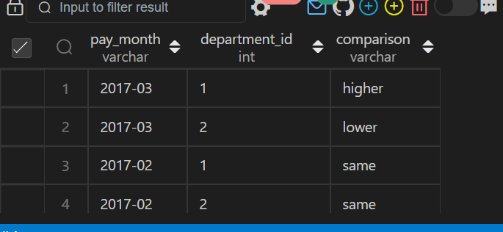

**Q97.**

CREATE TABLE Activity(

player_id int,

device_id int,

event_date date,

games_played int

);

INSERT INTO Activity VALUES(1,2,'2016-03-01',5),(1,2,'2016-05-02',6),(2,3,'2017-06-25',1),

(3,1,'2016-03-02',0),(3,4,'2018-07-03',5);

**Write an SQL query to report the first login date for each player.**

**SQL QUERY:**

select player_id, min(event_date) as first_login

from Activity

group by player_id;

**OUTPUT:**



**Q98.**

CREATE TABLE Players(

player_id int PRIMARY KEY,

group_id varchar(30)

);

 CREATE TABLE Matches(

match_id int primary KEY,

first_player int,

second_player int,

first_score int,

second_score int

 );

 insert into Players VALUES(15,1),

(25,1),

(30,1),

(45,1),

(10,2),

(35,2),

(50,2),

(20,3),

(40,3);

insert into Matches VALUES(1,15,45,3,0),

(2,30,25,1,2),(3,30,25,1,2),

(4,40,20,5,2),(5,35,50,1,1);

**The winner in each group is the player who scored the maximum total points within the group. In the case of a tie, the lowest player_id wins. Write an SQL query to find the winner in each group.**

**Query:**

select group_id,player_id

from (

    select sc.group_id group_id, sc.player_id player_id,

       rank() over (partition by sc.group_id order by sum(sc.score) desc, sc.player_id asc) as rnk

    from(

        select p.group_id group_id,

         p.player_id player_id ,

         sum(m.first_score) as score

        from Players p

        inner join Matches m

        on p.player_id = m.first_player

        group by p.group_id,p.player_id

        union all

        select p.group_id group_id,

         p.player_id player_id ,

        sum(second_score) as score

        from Players p

        inner join Matches m

        on p.player_id = m.second_player

        group by p.group_id,p.player_id

    ) sc

    group by sc.group_id,sc.player_id

) A

where rnk = 1;

**OUTPUT:**



**Q99)**

CREATE TABLE Student

(student_id INT,

 student_name VARCHAR(32));

INSERT INTO Student

VALUES

(1, 'Daniel'),

(2, 'Jade'),

(3, 'Stella'),

(4, 'Jonathan'),

(5, 'Will');

CREATE TABLE Exam

(exam_id INT,

 student_id INT,

 score INT);

 INSERT INTO Exam

 VALUES

 (10, 1, 70),

 (10, 2, 80),

 (10, 3, 90),

 (20, 1, 80),

 (30, 1, 70),

 (30, 3, 80),

 (30, 4, 90),

 (40, 1, 60),

 (40, 2, 70),

 (40, 4, 80);

**A quiet student is the one who took at least one exam and did not score the high or the low score. Write an SQL query to report the students (student_id, student_name) being quiet in all exams. Do not return the student who has never taken any exam**

**Query:**

WITH TMP AS

 (SELECT DISTINCT(student_id) AS student_id

 FROM (SELECT student_id,

     RANK() OVER(PARTITION BY exam_id

           ORDER BY Score) AS r1,

     RANK() OVER(PARTITION BY exam_id

           ORDER BY Score DESC) AS r2

 FROM Exam) AS T

 WHERE r1 = 1 OR r2 = 1),

 TMP1 AS

 (SELECT DISTINCT(student_id) AS student_id

  FROM Exam

  WHERE student_id NOT IN (SELECT student_id FROM TMP))

SELECT A.student_id, B.student_name

FROM TMP1 AS A

LEFT OUTER JOIN Student AS B

ON A.student_id = B.student_id

ORDER BY student_id;

**OUPUT:**

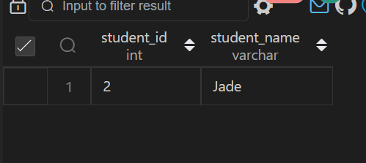

**Q100)**

CREATE TABLE Student

(student_id INT,

 student_name VARCHAR(32));

INSERT INTO Student

VALUES

(1, 'Daniel'),

(2, 'Jade'),

(3, 'Stella'),

(4, 'Jonathan'),

(5, 'Will');

CREATE TABLE Exam

(exam_id INT,

 student_id INT,

 score INT);

 INSERT INTO Exam

 VALUES

 (10, 1, 70),

 (10, 2, 80),

 (10, 3, 90),

 (20, 1, 80),

 (30, 1, 70),

 (30, 3, 80),

 (30, 4, 90),

 (40, 1, 60),

 (40, 2, 70),

 (40, 4, 80);

**A quiet student is the one who took at least one exam and did not score the high or the low score. Write an SQL query to report the students (student_id, student_name) being quiet in all exams. Do not return the student who has never taken any exam**

**Query:**

WITH TMP AS

 (SELECT DISTINCT(student_id) AS student_id

 FROM (SELECT student_id,

     RANK() OVER(PARTITION BY exam_id

           ORDER BY Score) AS r1,

     RANK() OVER(PARTITION BY exam_id

           ORDER BY Score DESC) AS r2

 FROM Exam) AS T

 WHERE r1 = 1 OR r2 = 1),

 TMP1 AS

 (SELECT DISTINCT(student_id) AS student_id

  FROM Exam

  WHERE student_id NOT IN (SELECT student_id FROM TMP))

SELECT A.student_id, B.student_name

FROM TMP1 AS A

LEFT OUTER JOIN Student AS B

ON A.student_id = B.student_id

ORDER BY student_id;

**OUPUT:**



**Q101)**

create table UserActivity(

username varchar(30),

activity varchar(30),

startDate Date,

endDate Date

);

insert into UserActivity VALUES('Alice','Travel', '2020-02-12','2020-02-20'),

('Alice','Dancing','2020-02-21','2020-02-23'),

('Alice','Travel','2020-02-24','2020-02-28'),

('Bob','Travel','2020-02-11','2020-02-18');

**Write an SQL query to show the second most recent activity of each user. If the user only has one activity, return that one. A user cannot perform more than one activity at the same time.**

**Query:**

select username,activity,startDate,endDate from  (

select * , rank()over(partition by username order by startDate desc) as rnk,

count(username) over( partition by username order by startDate desc) as cnt

from UserActivity)tmp  where rnk=2 or cnt=1;

**OUPUT:**

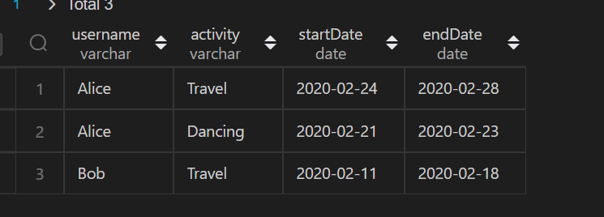

**Q102)**

create table UserActivity(

username varchar(30),

activity varchar(30),

startDate Date,

endDate Date

);

insert into UserActivity VALUES('Alice','Travel', '2020-02-12','2020-02-20'),

('Alice','Dancing','2020-02-21','2020-02-23'),

('Alice','Travel','2020-02-24','2020-02-28'),

('Bob','Travel','2020-02-11','2020-02-18');

**Write an SQL query to show the second most recent activity of each user. If the user only has one activity, return that one. A user cannot perform more than one activity at the same time.**

**Query:**

select username,activity,startDate,endDate from  (

select * , rank()over(partition by username order by startDate desc) as rnk,

count(username) over( partition by username order by startDate desc) as cnt

from UserActivity)tmp  where rnk=2 or cnt=1;

**OUPUT:**



**Q103)**

CREATE TABLE STUDENTS (

    ID INTEGER,

    NAME VARCHAR(30),

    MARKS VARCHAR(30)

);

insert into STUDENTS  VALUES(1,'Ashley',81),(2,'Samantha',75),(4,'Julia',76),(3,'Belvet',84);

**Query the Name of any student in STUDENTS who scored higher than 75 Marks.**

**Query:**

SELECT name from STUDENTS  where MARKS >75 order by right(name,3);

**OUTPUT:**



**104)**

CREATE TABLE EMPLOYEE(

    employee_id INTEGER,

    name varchar(30),

    months INTEGER,

    salary INTEGER

);

insert into EMPLOYEE VALUES(1228,'Rose',15,1968),(33645,'Angela',1,3443),(45692,'Frank',17,1608),

(56118,'Pratick',7,1345),(59725,'Lisa',11,2330),

(74197,'Kimberly',16,4372);

Write a query that prints a list of employee names (i.e.: the name attribute) from the Employee table in alphabetical order.

**Query:**

select * from EMPLOYEE order by name;

**OUTPUT:**



**Q105.**

CREATE TABLE EMPLOYEE(

    employee_id INTEGER,

    name varchar(30),

    months INTEGER,

    salary INTEGER

);

insert into EMPLOYEE VALUES(1228,'Rose',15,1968),(33645,'Angela',1,3443),(45692,'Frank',17,1608),

(56118,'Pratick',7,1345),(59725,'Lisa',11,2330),

(74197,'Kimberly',16,4372),(78454,'Bonnie',8,1771),

(83565,'Michele',6,2017),(98607,'Todd',5,3396),

(99989,'Joe',9,3573);

**Write a query that prints a list of employee names (i.e.: the name attribute) for employees in Employee having a salary greater than $2000 per month who have been employees for less than 10 months. Sort your result by ascending employee_id**.

**Query:**

select * from EMPLOYEE where salary > 2000 and months < 10 order by  employee_id  ;

**OUTPUT:**



**Q106)**

create table TRIANGLES(

    A integer,

    B integer,

    C integer

);

insert into TRIANGLES VALUES(20,20,23),(20,20,20),(20,21,22),(13,14,30);

Write a query identifying the type of each record in the TRIANGLES table using its three side lengths.

**Query:**

SELECT CASE

WHEN A + B <= C OR A + C <= B OR B + C <= A THEN 'Not A Triangle'

WHEN A = B AND B = C THEN 'Equilateral'

WHEN A = B OR B = C OR A = C THEN 'Isosceles'

ELSE 'Scalene'

END as result

FROM TRIANGLES;

**OUTPUT:**



**Q107.**

create table  EMployees(ID int, Name Varchar(20), Salary int);

insert into EMployees Values(1,'Kristeen',1420),(2,'Ashley',2006),(3,'Julia',2210),(4,'Maria',3000);

**Write a query calculating the amount of error (i.e.: actual - miscalculated average monthly salaries), and round it up to the next integer.**

**Query:**

select ceil(avg(salary) - avg(replace(salary, '0', ''))) from EMployees;

**Output:**

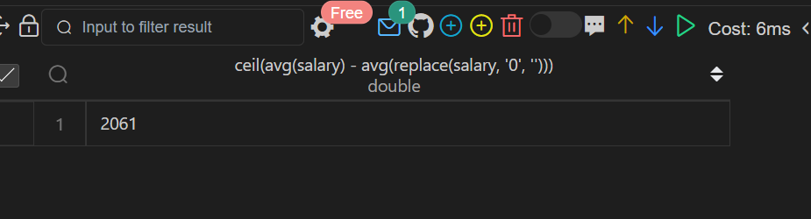

**Q108.**

CREATE TABLE EMPLOYEE(

    employee_id INTEGER,

    name varchar(30),

    months INTEGER,

    salary INTEGER

);

insert into EMPLOYEE VALUES(1228,'Rose',15,1968),(33645,'Angela',1,3443),(45692,'Frank',17,1608),

(56118,'Pratick',7,1345),(59725,'Lisa',11,2330),

(74197,'Kimberly',16,4372);

**Write a query to find the maximum total earnings for all employees as well as the total number of employees who have maximum total earnings.**

**Query:**

select * from EMPLOYEE order by months*salary;

**Output:**

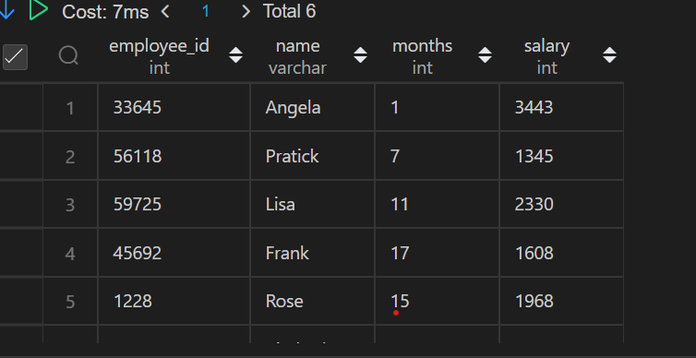

**Q109)**

CREATE TABLE OCCUPATIONS(

    Name  VARCHAR(30),

    Occupation VARCHAR(30)

);

insert into OCCUPATIONS values('julia','Actor'),('Samantha','Doctor'),('Maria','Actor'),('Meera','Singer'),('Ashely','professor'),

('Ketty','Professor'),('Christeen','Professor'),('Jane','Actor'),

('Jenny','Doctor'),('Priya','Singer');

**Query the number of occurrences of each occupation in OCCUPATIONS. Sort the occurrences in ascending order, and output**

**Query:**

(SELECT CONCAT(Name,'(',SUBSTRING(OCCUPATION,1,1),')') from OCCUPATIONS order by Name asc )  UNION

(SELECT CONCAT('There are a total of ',count(OCCUPATION),' ',lower(OCCUPATION),'s','.') from OCCUPATIONS group by OCCUPATION ORDER BY COUNT(occupation),occupation asc);

**OUTPUT:**

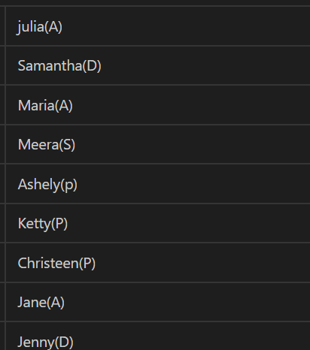

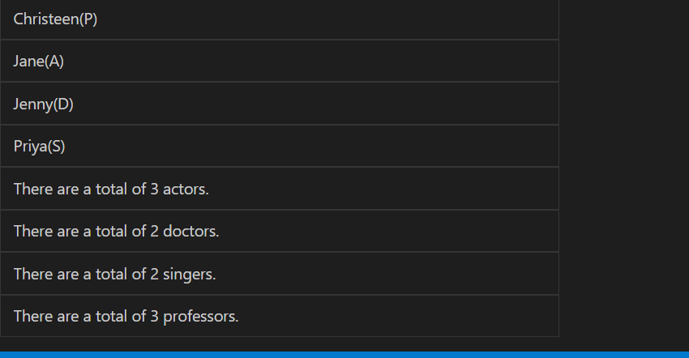

**Q110 .**

CREATE TABLE OCCUPATIONS(

    Name  VARCHAR(30),

    Occupation VARCHAR(30)

);

insert into OCCUPATIONS values('julia','Actor'),('Samantha','Doctor'),('Maria','Actor'),('Meera','Singer'),('Ashely','professor'),

('Ketty','Professor'),('Christeen','Professor'),('Jane','Actor'),

('Jenny','Doctor'),('Priya','Singer');

**Query the number of occurrences of each occupation in OCCUPATIONS. Sort the occurrences in ascending order, and output**

**Query**

set @d=0,@p=0,@s=0,@a=0;

 select max(dname),max(pname),max(sname),max(aname) from(select

case when Occupation='Doctor' then Name end as dname,

case when Occupation='Professor' then Name end as pname,

case when Occupation='Singer' then Name end as sname,

case when Occupation='Actor' then Name end as aname,

case

    when Occupation='Doctor' then (@d:=@d+1)

    when Occupation='Professor' then (@p:=@p+1)

    when Occupation='Singer' then (@s:=@s+1)

    when Occupation='Actor' then(@a:=@a+1)

end as count from  OCCUPATIONS order by Name ) as t group by count;

**OUTPUT**

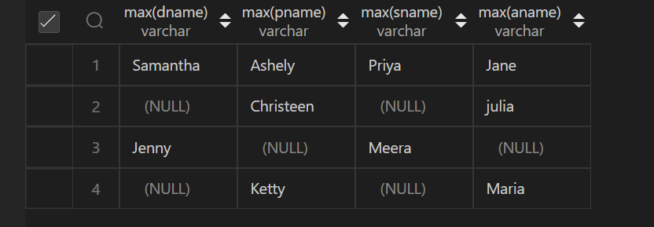

**Q111.**

CREATE TABLE BST(

    N INT,

    P INT

);

INSERT INTO BST VALUES(1,2),(3,2),

(6,8),(9,8),(2,5),(8,5),(5,NULL);

**Write a query to find the node type of Binary Tree ordered by the value of the node.**

**Query**

select N,

CASE

 WHEN P is NULL then 'Root'

 WHEN N in (select P from BST) then 'Inner'

 else 'Leaf'

 end

 from BST order by N;

**OUTPUT**

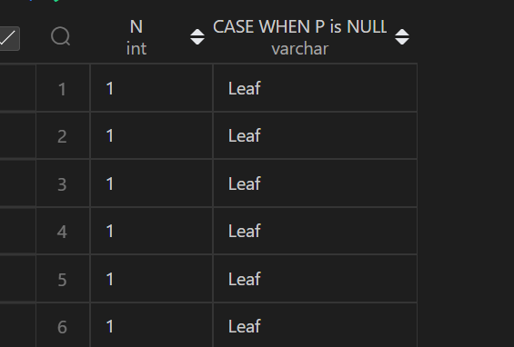

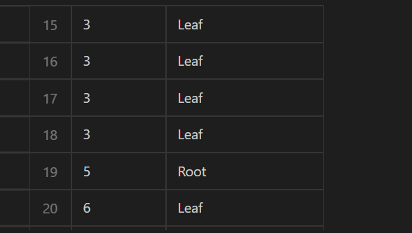

**Q113.**

**Write a query to print all prime numbers less than or equal to 1000.**

**Query**

create table prime_number(numbers int);

DECLARE @nr INT;

DECLARE @divider INT;

DECLARE @prime INT;

select @nr=1;

while @nr < 1000

    BEGIN

    SELECT @divider = @nr-1

    SELECT @prime = 1

    WHILE @divider > 1

        BEGIN

        IF @nr % @divider = 0

            SELECT @prime = 0;

        SELECT @divider = @divider-1

        END

    IF @prime = 1 AND @nr <> 1

        INSERT INTO prime_number(numbers) values(@nr);

    SELECT @nr= @nr+1;

    END

SELECT STRING_AGG(numbers,'&') FROM prime_number;

**OUTPUT**

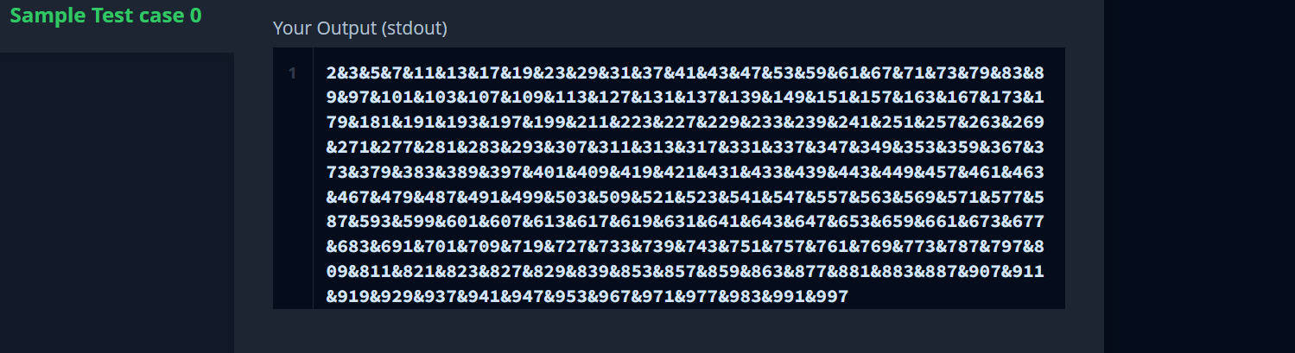

**Q114.**

**P(R) represents a pattern drawn by Julia in R rows. The following pattern represents P(5)**

**Query**

DECLARE @I INT;

SELECT @I=1;

WHILE  @I < 5

begin

    PRINT REPLICATE('* ',@I)

    SET @I=@I+1

END

**OUTPUT**

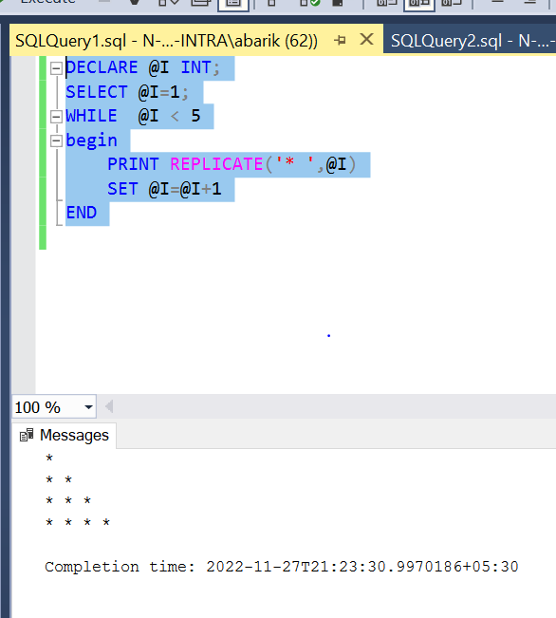

**Q115.**

**P(R) represents a pattern drawn by Julia in R rows. The following pattern represents P(5)**

**Query**

DECLARE @I INT;

SET @I=5;

WHILE  @I >=1

begin

    PRINT REPLICATE('* ',@I)

    SET @I=@I-1

END

**OUTPUT**

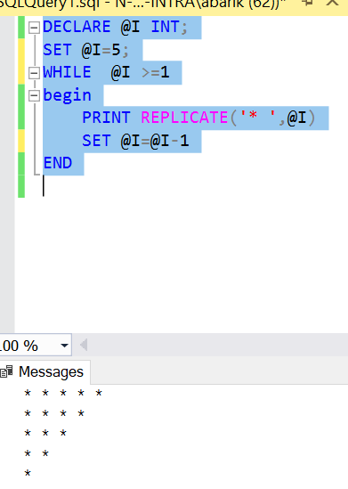

**Q116.**

CREATE TABLE FUN(

   X INT,

   Y INT

   );

   INSERT INTO FUN VALUES(20,20),(20,20),

   (20,21),(23,22),(22,23),(21,20);

**Write a query to output all such symmetric pairs in ascending order by the value of X. List the rows such that X1 ≤ Y1.**

**Query**

 select  distinct A.x,A.y from

(select x,y, row_number() over(order by x asc) as r from FUN) A join

(select x,y, row_number() over(order by x asc) as r from FUN) B on A.x=B.y and B.x =A.y  and A.r!=B.r and A.x<=A.y  order by A.x;

**OUTPUT**

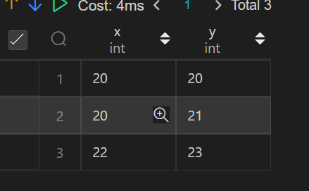

**Q117.**

CREATE TABLE STUDENTS (

    ID INTEGER,

    NAME VARCHAR(30),

    MARKS VARCHAR(30)

);

insert into STUDENTS  VALUES(1,'Ashley',81),(2,'Samantha',75),(4,'Julia',76),(3,'Belvet',84);

**Query the Name of any student in STUDENTS who scored higher than 75 Marks.**

**Query:**

SELECT name from STUDENTS  where MARKS >75 order by right(name,3);

**OUTPUT:**



**Q118.**

CREATE TABLE EMPLOYEE(

    employee_id INTEGER,

    name varchar(30),

    months INTEGER,

    salary INTEGER

);

insert into EMPLOYEE VALUES(1228,'Rose',15,1968),(33645,'Angela',1,3443),(45692,'Frank',17,1608),

(56118,'Pratick',7,1345),(59725,'Lisa',11,2330),

(74197,'Kimberly',16,4372);

**Write a query that prints a list of employee names (i.e.: the name attribute) from the Employee table in alphabetical order.**

**Query:**

select * from EMPLOYEE order by name;

**OUTPUT:**



**Q119.**

CREATE TABLE EMPLOYEE(

    employee_id INTEGER,

    name varchar(30),

    months INTEGER,

    salary INTEGER

);

insert into EMPLOYEE VALUES(1228,'Rose',15,1968),(33645,'Angela',1,3443),(45692,'Frank',17,1608),

(56118,'Pratick',7,1345),(59725,'Lisa',11,2330),

(74197,'Kimberly',16,4372),(78454,'Bonnie',8,1771),

(83565,'Michele',6,2017),(98607,'Todd',5,3396),

(99989,'Joe',9,3573);

**Write a query that prints a list of employee names (i.e.: the name attribute) for employees in Employee having a salary greater than $2000 per month who have been employees for less than 10 months. Sort your result by ascending employee_id**.

**Query:**

select * from EMPLOYEE where salary > 2000 and months < 10 order by  employee_id  ;

**OUTPUT:**



**Q120**

create table TRIANGLES(

    A integer,

    B integer,

    C integer

);

insert into TRIANGLES VALUES(20,20,23),(20,20,20),(20,21,22),(13,14,30);

Write a query identifying the type of each record in the TRIANGLES table using its three side lengths.

**Query:**

SELECT CASE

WHEN A + B <= C OR A + C <= B OR B + C <= A THEN 'Not A Triangle'

WHEN A = B AND B = C THEN 'Equilateral'

WHEN A = B OR B = C OR A = C THEN 'Isosceles'

ELSE 'Scalene'

END as result

FROM TRIANGLES;

**OUTPUT:**



**Q121)**

create table user_transactions(

transaction_id integer,

product_id integer,

spend decimal,

transaction_date datetime

);

;

insert into user_transactions VALUES(1341,123424,1500.60,STR_TO_DATE("12/31/2019 12:00:00",'%m/%d/%Y %T')),

(1423,123424,1000.20,STR_TO_DATE('12/31/2020 12:00:00','%m/%d/%Y %T')),

(1623,123424,1246.44,STR_TO_DATE('12/31/2021 12:00:00','%m/%d/%Y %T')),

(1322,123424,2145.32,STR_TO_DATE('12/31/2022 12:00:00','%m/%d/%Y %T'));

**Write a query to obtain the year-on-year growth rate for the total spend of each product for each year.**

**Query:**

WITH yearsum AS

(

SELECT EXTRACT(YEAR FROM transaction_date) as year, product_id, SUM(spend) as spend

FROM user_transactions

GROUP BY 1,2

)

SELECT a.year, a.product_id,

a.spend as curr_year_spend,

b.spend as prev_year_spend,

ROUND(100.00*(a.spend - b.spend)/b.spend,2) as yoy_rate

FROM yearsum a

LEFT JOIN yearsum b ON a.year-1=b.year AND a.product_id = b.product_id

ORDER BY 2,1;

**Output:**



**Q122)**

 create table inventory(

item_id integer,

item_type varchar(30),

item_category varchar(30),

square_footage decimal

 );

insert into inventory VALUES (1374,'prime_eligible' ,'mini refrigerator',68.00),

(4245,'not_prime standing','lamp',26.40),

(2452,'prime_eligible','television',85.00),

(3255,'not_prime','side table',22.60),

(1672,'prime_eligible','laptop',8.50);

**Write a SQL query to find the number of prime and non-prime items that can be stored in the 500,000 square feet warehouse. Output the item type and number of items to be stocked.**

**Query:**

SELECT item_type,

case

when item_type = 'prime_eligible'

then Floor(500000/sum(square_footage))*count(item_type)

else floor((500000 -(select(floor(500000/sum(square_footage)))*sum(square_footage) from inventory where item_type = 'prime_eligible'))/sum(square_footage))*Count(item_type)

end

from

inventory

group by item_type

order by item_type desc;

**Output:**



**Q123)**

Create Table user_actions (

users_id int,

event_id int,

event_type varchar(50),

event_date datetime );

nsert into user_actions Values(445, 7765 ,'sign-in',STR_TO_DATE('05/31/2022 12:00:00','%m/%d/%Y %T'));

Insert into user_actions Values(445, 3634 ,'like',STR_TO_DATE('06/05/2022 12:00:00','%m/%d/%Y %T'));

Insert into user_actions Values(742, 6458 ,'sign-in', STR_TO_DATE('07/03/2022 12:00:00','%m/%d/%Y %T'));

Insert into user_actions Values(742, 1374 ,'comment', STR_TO_DATE('07/19/2022 12:00:00','%m/%d/%Y %T'));

**Assume you have the table below containing information on Facebook user actions. Write a query to obtain the active user retention in July 2022. Output the month (in numerical format 1, 2, 3) and the number of monthly active users (MAUs).**

**Query:**

SELECT EXTRACT(MONTH FROM a1.event_date) as month, COUNT(DISTINCT a1.users_id) as monthly_active_users

from user_actions as a1,user_actions as a2

where a1.users_id = a2.users_id AND

EXTRACT(MONTH FROM a1.event_date) = 7

AND EXTRACT(MONTH FROM a2.event_date) =6

AND EXTRACT(YEAR FROM a1.event_date) = 2022

AND EXTRACT(YEAR FROM a2.event_date) =2022

AND a1.event_type in ( 'sign-in', 'like', 'comment') AND

a2.event_type in ('sign-in', 'like', 'comment')

GROUP BY month;

**Output:**



**Q124)**

Google's marketing team is making a Superbowl commercial and needs a simple statistic to put on their TV ad: the median number of searches a person made last year. However, at Google scale, querying the 2 trillion searches is too costly. Luckily, you have access to the summary table which tells you the number of searches made last year and how many Google users fall into that bucket.

Query

WITH expanded AS(

  SELECT searches

  FROM search_frequency

  GROUP BY searches, GENERATE_SERIES(1,num_users)

)

SELECT PERCENTILE_CONT(0.5) WITHIN GROUP (ORDER BY searches) AS median

FROM expanded

**Output**



**Q127)**

**Sometimes, payment transactions are repeated by accident; it could be due to user error, API failure or a retry error that causes a credit card to be charged twice. Using the transactions table, identify any payments made at the same merchant with the same credit card for the same amount within 10 minutes of each other. Count such repeated payments. Level - Hard Hint- Use Partition and order by**

Query

select count(t1.merchant_id) as payment_count

from transactions t1

join transactions t2

on t1.merchant_id=t2.merchant_id

and t1.credit_card_id=t2.credit_card_id

and t1.amount=t2.amount

and t1.transaction_id<t2.transaction_id

where (date_part('minute',t2.transaction_timestamp)-date_part('minute',t1.transaction_timestamp))<=10

and  date_part('hour',t1.transaction_timestamp)=date_part('hour',t2.transaction_timestamp)

;;

**OUTPUT**



**Q129)**

CREATE TABLE Scores(

player_name varchar(30),

gender varchar(30),

day date,

score_points int,

constraint pk PRIMARY KEY((gender, day)

);

insert into Scores values('Aron','F','2020-01-01', 17),

('Alice','F','2020-01-07',23),

('Bajrang','M','2020-01-07',7),

('Khali','M','2019-12-25',11),

('Slaman','M','2019-12-30', 13),

('Joe','M','2019-12-31', 3),

('Jose','M','2019-12-18',2),

('Priya','F','2019-12-31',23),

('Priyanka','F','2019-12-30',17);

**Write an SQL query to find the total score for each gender on each day.**

**Query:**

select gender,day, sum(score_points) over(partition by gender order by gender,day  rows BETWEEN unbounded preceding and current row) as total from  Scores;

**OUTPUT:**



**130)**

CREATE TABLE person(

id int PRIMARY KEY,

name varchar(30),

phone_number varchar(30)

);

 CREATE TABLE country(

name varchar(30),

country_code varchar(30) PRIMARY KEY

 );

  CREATE TABLE calls(

 caller_id int,

callee_id int,

duration int

  );

insert into person values(3 , "Jonathan", "051-1234567"),(12, "Elvis", "051-7654321"),(1 , "Moncef", "212-1234567"),

(2 , "Maroua", "212-6523651"),(7 , "Meir", "972-1234567"),(9 , "Rachel", "972-0011100");

insert into country  values("Peru", '051'),("Israel", '972'),("Morocco", '212'),("Germany", '049'),("Ethiopia", '251');

insert into calls values (1, 9, 33),(2, 9, 4),(1, 2, 59),(3, 12, 102),(3, 12, 330),(12, 3, 5),(7, 9, 13),(7, 1, 3),(9, 7, 1),(1, 7, 7);

**Write an SQL query to find the countries where this company can invest. Return the result table in any order**

**Query:**

SELECT cc.name from person p inner join  calls c on p.id=c.caller_id or p.id=c.callee_id

 inner join country cc on cc.country_code=left(p.phone_number,3) group by cc.name having avg(c.duration) >

(select avg(duration) from calls);

**OUTPUT:**



**Q131.**

Create table If Not Exists Numbers (

       Number int,

       Frequency int);

insert into Numbers (Number, Frequency) values ('0', '7');

insert into Numbers (Number, Frequency) values ('1', '1');

insert into Numbers (Number, Frequency) values ('2', '3');

insert into Numbers (Number, Frequency) values ('3', '1');

**Write an SQL query to report the median of all the numbers in the database after decompressing the Numbers table. Round the median to one decimal point**.

**Query:**

select

    avg(number) median

from

   Numbers n

where

    n.frequency >= abs(

                        (select sum(Frequency) from Numbers where Number<=n.number)

                        -

                        (select sum(Frequency) from Numbers where Number>=n.number));

**OUTPUT:**



**Q132.**

Create table If Not Exists salary (

    id int,

    employee_id int,

    amount int,

    pay_date date);

Create table If Not Exists employee (

    employee_id int,

    department_id int);

insert into salary

    (id, employee_id, amount, pay_date)

values

    ('1', '1', '9000', '2017/03/31');

insert into salary

    (id, employee_id, amount, pay_date)

values

    ('2', '2', '6000', '2017/03/31');

insert into salary

    (id, employee_id, amount, pay_date)

values

    ('3', '3', '10000', '2017/03/31');

insert into salary

    (id, employee_id, amount, pay_date)

values

    ('4', '1', '7000', '2017/02/28');

insert into salary

    (id, employee_id, amount, pay_date)

values

    ('5', '2', '6000', '2017/02/28');

insert into salary

    (id, employee_id, amount, pay_date)

values

    ('6', '3', '8000', '2017/02/28');

insert into employee

    (employee_id, department_id)

values

    ('1', '1');

insert into employee

    (employee_id, department_id)

values

    ('2', '2');

insert into employee

    (employee_id, department_id)

values

    ('3', '2');

**Write an SQL query to report the comparison result (higher/lower/same) of the average salary of employees in a department to the company's average salary.**

**Query:**

select

    pay_month,

    department_id,

    case when dept_avg > comp_avg then 'higher' when dept_avg < comp_avg then 'lower' else 'same' end comparison

from (

        select  date_format(b.pay_date, '%Y-%m') pay_month, a.department_id, avg(b.amount) dept_avg,  d.comp_avg

        from employee a

        inner join salary b

            on (a.employee_id = b.employee_id)

        inner join (select date_format(c.pay_date, '%Y-%m') pay_month, avg(c.amount) comp_avg

                    from salary c

                    group by date_format(c.pay_date, '%Y-%m')) d

            on ( date_format(b.pay_date, '%Y-%m') = d.pay_month)

group by date_format(b.pay_date, '%Y-%m'), department_id, d.comp_avg) final

**OUTPUT:**

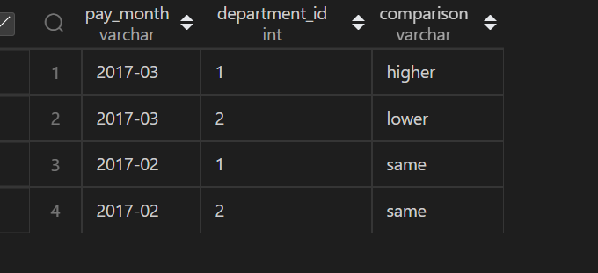

**Q133.**

CREATE TABLE Players(

player_id int PRIMARY KEY,

group_id varchar(30)

);

 CREATE TABLE Matches(

match_id int primary KEY,

first_player int,

second_player int,

first_score int,

second_score int

 );

 insert into Players VALUES(15,1),

(25,1),

(30,1),

(45,1),

(10,2),

(35,2),

(50,2),

(20,3),

(40,3);

insert into Matches VALUES(1,15,45,3,0),

(2,30,25,1,2),(3,30,25,1,2),

(4,40,20,5,2),(5,35,50,1,1);

**The winner in each group is the player who scored the maximum total points within the group. In the case of a tie, the lowest player_id wins. Write an SQL query to find the winner in each group.**

**Query:**

select group_id,player_id

from (

    select sc.group_id group_id, sc.player_id player_id,

       rank() over (partition by sc.group_id order by sum(sc.score) desc, sc.player_id asc) as rnk

    from(

        select p.group_id group_id,

         p.player_id player_id ,

         sum(m.first_score) as score

        from Players p

        inner join Matches m

        on p.player_id = m.first_player

        group by p.group_id,p.player_id

        union all

        select p.group_id group_id,

         p.player_id player_id ,

        sum(second_score) as score

        from Players p

        inner join Matches m

        on p.player_id = m.second_player

        group by p.group_id,p.player_id

    ) sc

    group by sc.group_id,sc.player_id

) A

where rnk = 1;

**OUTPUT:**



**Q136.**

CREATE TABLE Student

(student_id INT,

 student_name VARCHAR(32));

INSERT INTO Student

VALUES

(1, 'Daniel'),

(2, 'Jade'),

(3, 'Stella'),

(4, 'Jonathan'),

(5, 'Will');

CREATE TABLE Exam

(exam_id INT,

 student_id INT,

 score INT);

 INSERT INTO Exam

 VALUES

 (10, 1, 70),

 (10, 2, 80),

 (10, 3, 90),

 (20, 1, 80),

 (30, 1, 70),

 (30, 3, 80),

 (30, 4, 90),

 (40, 1, 60),

 (40, 2, 70),

 (40, 4, 80);

**A quiet student is the one who took at least one exam and did not score the high or the low score. Write an SQL query to report the students (student_id, student_name) being quiet in all exams. Do not return the student who has never taken any exam**

**Query:**

WITH TMP AS

 (SELECT DISTINCT(student_id) AS student_id

 FROM (SELECT student_id,

     RANK() OVER(PARTITION BY exam_id

           ORDER BY Score) AS r1,

     RANK() OVER(PARTITION BY exam_id

           ORDER BY Score DESC) AS r2

 FROM Exam) AS T

 WHERE r1 = 1 OR r2 = 1),

 TMP1 AS

 (SELECT DISTINCT(student_id) AS student_id

  FROM Exam

  WHERE student_id NOT IN (SELECT student_id FROM TMP))

SELECT A.student_id, B.student_name

FROM TMP1 AS A

LEFT OUTER JOIN Student AS B

ON A.student_id = B.student_id

ORDER BY student_id;

**OUPUT:**



**Q137.**

create table UserActivity(

username varchar(30),

activity varchar(30),

startDate Date,

endDate Date

);

insert into UserActivity VALUES('Alice','Travel', '2020-02-12','2020-02-20'),

('Alice','Dancing','2020-02-21','2020-02-23'),

('Alice','Travel','2020-02-24','2020-02-28'),

('Bob','Travel','2020-02-11','2020-02-18');

**Write an SQL query to show the second most recent activity of each user. If the user only has one activity, return that one. A user cannot perform more than one activity at the same time.**

**Query:**

select username,activity,startDate,endDate from  (

select * , rank()over(partition by username order by startDate desc) as rnk,

count(username) over( partition by username order by startDate desc) as cnt

from UserActivity)tmp  where rnk=2 or cnt=1;

**Q139.**

CREATE TABLE STUDENTS (

    ID INTEGER,

    NAME VARCHAR(30),

    MARKS VARCHAR(30)

);

insert into STUDENTS  VALUES(1,'Ashley',81),(2,'Samantha',75),(4,'Julia',76),(3,'Belvet',84);

**Query the Name of any student in STUDENTS who scored higher than 75 Marks.**

**Query:**

SELECT name from STUDENTS  where MARKS >75 order by right(name,3);

**OUTPUT:**



**Q145**

CREATE TABLE OCCUPATIONS(

    Name  VARCHAR(30),

    Occupation VARCHAR(30)

);

insert into OCCUPATIONS values('julia','Actor'),('Samantha','Doctor'),('Maria','Actor'),('Meera','Singer'),('Ashely','professor'),

('Ketty','Professor'),('Christeen','Professor'),('Jane','Actor'),

('Jenny','Doctor'),('Priya','Singer');

**Query the number of occurrences of each occupation in OCCUPATIONS. Sort the occurrences in ascending order, and output**

**Query:**

(SELECT CONCAT(Name,'(',SUBSTRING(OCCUPATION,1,1),')') from OCCUPATIONS order by Name asc )  UNION

(SELECT CONCAT('There are a total of ',count(OCCUPATION),' ',lower(OCCUPATION),'s','.') from OCCUPATIONS group by OCCUPATION ORDER BY COUNT(occupation),occupation asc);

**OUTPUT:**





**Q146.**

CREATE TABLE OCCUPATIONS(

    Name  VARCHAR(30),

    Occupation VARCHAR(30)

);

insert into OCCUPATIONS values('julia','Actor'),('Samantha','Doctor'),('Maria','Actor'),('Meera','Singer'),('Ashely','professor'),

('Ketty','Professor'),('Christeen','Professor'),('Jane','Actor'),

('Jenny','Doctor'),('Priya','Singer');

**Query the number of occurrences of each occupation in OCCUPATIONS. Sort the occurrences in ascending order, and output**

**Query**

set @d=0,@p=0,@s=0,@a=0;

 select max(dname),max(pname),max(sname),max(aname) from(select

case when Occupation='Doctor' then Name end as dname,

case when Occupation='Professor' then Name end as pname,

case when Occupation='Singer' then Name end as sname,

case when Occupation='Actor' then Name end as aname,

case

    when Occupation='Doctor' then (@d:=@d+1)

    when Occupation='Professor' then (@p:=@p+1)

    when Occupation='Singer' then (@s:=@s+1)

    when Occupation='Actor' then(@a:=@a+1)

end as count from  OCCUPATIONS order by Name ) as t group by count;

**OUTPUT**



**Q147.**

CREATE TABLE BST(

    N INT,

    P INT

);

INSERT INTO BST VALUES(1,2),(3,2),

(6,8),(9,8),(2,5),(8,5),(5,NULL);

**Write a query to find the node type of Binary Tree ordered by the value of the node.**

**Query**

select N,

CASE

 WHEN P is NULL then 'Root'

 WHEN N in (select P from BST) then 'Inner'

 else 'Leaf'

 end

 from BST order by N;

**OUTPUT**





**Q149.**

CREATE TABLE FUN(

   X INT,

   Y INT

   );

   INSERT INTO FUN VALUES(20,20),(20,20),

   (20,21),(23,22),(22,23),(21,20);

**Write a query to output all such symmetric pairs in ascending order by the value of X. List the rows such that X1 ≤ Y1.**

**Query**

 select  distinct A.x,A.y from

(select x,y, row_number() over(order by x asc) as r from FUN) A join

(select x,y, row_number() over(order by x asc) as r from FUN) B on A.x=B.y and B.x =A.y  and A.r!=B.r and A.x<=A.y  order by A.x;

**OUTPUT**

